FACULTY COUNCIL MEETING
Monday, February 3, 2020
1:15 PM to 2:15 PM – Reed 113

Faculty Council and Senate Website: http://behrend.psu.edu/for-faculty-staff/committees/faculty-senate- and-council

- Call to Order – Melanie Hetzel-Riggin, Faculty Council & Senate Chair

- Approval of the minutes from previous the Faculty Council Meeting

  - Lisa Eliot and Emily Cassano, unanimously

- Welcome and Comments from the Chair

- Report from the Chancellor, Ralph Ford

  - Dr. Ford is out of town

- Report from the Associate Dean of Academic Affairs, Pam Silver
  - Strategic Plan is extended for next 5 years. The campuses and schools are asked to reflect and make their own proposals. It is important to remember that there are still ongoing projects from the previous plan, which will continue on.
    - The College plan is due on July 31. University is using a specific software and we have the template to follow.
    - Ken Miller is handling student affairs and campus living. Pam is handling the academic side. Ken and Pam are identifying leaders. Faculty Council will have an important role is assessing faculty success. There will be a parallel unit on student success, and recruitment and retention. Each unit is asked to create their own plan with mission, vision, and few goals; including the actionable plan and an assessment metric.
    - University is asking for the Mission, Vision, and goas by the end of February. More likely deadline is mid-March.
    - Several phases have been put in place – first phase asks the varied units to create their missions and visions which will be assessed for consistency. Second stage – actionable plan. Third – assessment plan. This might take us into June.
    - Faculty and schools are already aware of the process and the structure of the process, with leaders and team identified. Pam would like for this to be a ground up effort with full involvement from faculty and staff, and when appropriate students.
Questions:
- How does out plan fit into the university plan?
- Our plan has to be aligned with the broader mission, vision, and pillars of the University. However, we can have ore discussion on how we can implement it here. Our last strategic plan was very well aligned with the University. Yet, with this year’s plan there will be some things specific to us like the Open Lab and the Vision of Behrend Graduate, etc.
- Do we have access to the ‘old” plan?
- Yes, Pam has provided the link in the email to all team/unit leaders with all of the information and useful tools.
(https://behrend.psu.edu/about-the-college/college-strategy-1/strategic-goals)

- Has this been in the works for a while? Or was this a surprise?

- We knew this was coming, however, not aware of the details. The documents and software were only provided mid-January
- What is the “reflection” document?
- A list of questions which included: How did we do on our last plan? What progress we made and what we would have done differently? And What things we would have done sooner? This was a three-page document which is also shared with unit/plan leaders.

  - Data Analytics major is moving forward.
  - PEZ is moving along and is ready for implementation
  - The faculty searchers are going well.

- Report from the Associate Dean of Research and Graduate Studies, Ivor Knight
  - March 6 deadline for undergraduate research. Each school has a committee, which reviews their applications before forwarding to Ivor’s office. The funding is generous of up to $4000. Those who are awarded these, will receive stipends, some funds for materials, and on-campus housing. Question:
- Can housing be extended to students who are funded by other grants?
-- This is a good conversation to have. Should be done on per case basis.
- Should this be written into grants? Or can the office provide some guideline for the faculty writing grants with information on housing?
  - This is really a case by case basis. But it’s $20/night for summer housing in apartments. Housing is happy to rent these.
- Why are we concerned about housing with this grant?
  - To make sure to give the students all the resources the university has for them to do their research, allowing students to be immersed and fully engaged in the research.
  - SEED grants are going out later in February. $7500 per faculty member.

- Report from University Senator, Lisa Mangel (Lisa’s notes from the meeting are attached)
  - There was an email from the Senate on Feb 3 with the link to survey. Please take it.
  - “More rivers to cross” report outlined the experiences of African American faculty across the university. The President outlines four areas where University can focus on moving forward.
  - Food and Housing Equity and Security. There will be task force which will focus on re- evaluation of spending
  - Informational reports
- Use of affordable course materials is strongly encouraged.
- Letter of recommendation (Appendix F). Formal requests from the students and cannot give a blanket permission, it has to be very specific for the kind of information they want to be shared and for all purposes. This has been a regulation for last 10 years. The form is on the registrar’s office website. (http://www.registrar.psu.edu/student_forms/request_for_recommendation_form.cfm) Melanie requested that Strategic Communication make the form available from the student navigation page as well
- Google suit is another resource along with Office 365. (Please find the chart attached below)
- Construction of Erie Hall was mentioned
  - Elections are happening soon. Candidates should be introduced in March.

- Reports from Committee Chairs

  - Academic Computer, Chuck Yeung
  - Athletics, Blair Tuttle
i. Continuing with charges.
  - Undergraduate Curricular Affairs, Lisa Elliott
- Submitted a report from last semester. There is an online link for folks to submit the requests for the course development, currently in use by the school of sicnece. If you have an idea for new course you can write your proposal and it will be sent to the school director and starts the process.
- Digital Learning Cooperative. Apparently, many folks do not know about this.
Pam -- If you have interest students in DLC, please talk to registrar’s. It seems that we need to be further educated about this resource and it can be used for very specific needs. This process has to be done in coordination with the registrar’s office and have high level of approval. This could be an interesting and useful tool which we might want to consider our strategic plan.
  - Faculty Affairs, Matt Swinarski
- When do the non-tenure track contract renewal letters go out?
Pam- They should have gone out today (Feb. 3). Across the university these letters go out in May. Behrend is unique in this case, where the letters go out early and this is taken into account
- Continue working on charges. Next meeting in on Feb. 5.
  - Graduate Affairs, Ken Louie
i. The committee is putting together a rough draft of the formal procedures for evaluating graduate program and course proposals at Behrend. The draft is based on all the information the committee gathered as well as all of the committee discussions last semester.
  - Research Committee, Jay Amicangelo
  - Scholarship and Awards, Omar Ashour
  - Student Life, Matt Levy
i. Evaluating the retention efforts. The committee is meeting with the necessary players and will be creating a report by the end of the academic year.
  - Undergraduate Studies, Joseph Previte
- Working with ACPC to educate faculty about Gen Eds. The suggestion is digitizing the flow chart created by Glen Khumera.
- SGA is asking about the process of handling grievances. Some students don’t feel that there is an anonymous process for grievances. The committee continues to emphasize the existing process.
  - Institutional Equity and Diversity, Boon Ong (by email)
- Kristen Comstock from the alumni office responded that, if needed, Andrea Myers can run a list of alumni if we need to local graduated international students, students of color and students from other underrepresented groups to obtain testimonials to use for recruitment and retention. The only problem is: ethnicity is only loaded into the database if the student self-reported.
- Engineering conducts open advising sessions in Residential hall in some evenings for upper-level Engineering dorm by asking for faculty members to volunteer an hour to do that. Jiawei recommends that maybe this can be done for students of diversity
- Office of Disability can give 10 min presentation as part of every School Meeting
- Library Testing Center usually have students who need special help. We could put resources near to these places to help spread the information about resources for those with physical, cognitive and other disabilities.
- Create “howto” Video by CTEI and place in faculty 101.

- We wonder if these students with physical and cognitive disabilities have common advisor who are specially trained, this will facilitate distribution of information to these students. If not, maybe we can suggest to the college to have this.

- Old Business
  - Faculty Engagement
  - Behrend Constitution Structure

- New Business
  - Renewal Contracts for NTT faculty (see above)
  - Campus Space Issues- Faculty feel that they are not consulted in their space use. How do faculty get involved? Pam – Ken Miller is the person to contact about space. Campus Master Plan is on the Behrend site and this information is available to all. (https://opp.psu.edu/sites/opp/files/penn_state_behrend_2016_master_plan_and_program.pdf)

  - Digital Learning Cooperative (see above)
  - Faculty Success, Engagement, and Governance are part of the charge for Faculty Senate in Strategic Plan. Please come and voice your opinions at the Senate meetings.

- Announcements
  - Faculty Council Dates Spring 2020: 3/2; 3/30; 4/27 @ 1:15 in Reed 113
  - Faculty Senate Dates Spring 2020: 2/10 @ 4pm in Reed 117 & 4/7 @ 4pm in Burke 180.

- Adjournment
  - Blair Tuttle and Matt Swinarski.

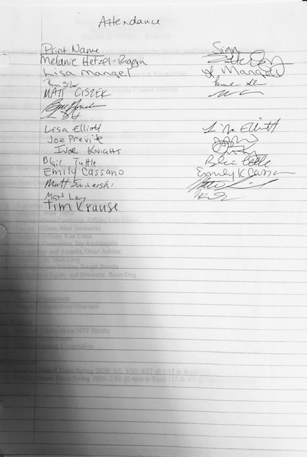

January 28th, 2020 University Faculty Senate

Agenda - https://senate.psu.edu/senators/agendas-records/january-28-2020-agenda/

Recorded meeting

https://live.libraries.psu.edu/Mediasite/Play/07d6fbc57fbf4db2bbb748c4d26aeb341d?catalog=8376d4b24dd145 7ea3bfe4cf9163feda21

*timestamps in the meeting video

1:57 More Rivers to Cross – paper on African American faculty treatment at PSU

3:10 University wide survey – February 3-28, 2020

4:40 Census – 2020 Penn State You Count

5:55 President Barron
- More Rivers to Cross
  - 4 main challenges
    - Stagnation in terms of numbers of underrepresented individuals**
    - Challenge in finding upper level leadership positions
    - Transparency with protection at the individual level****
    - Bias***

**Diversity fatigue – small numbers, same faculty members asked to represent a group over and over again
***12:25 SRTE and peer reviews
****17:05 maybe a small group/committee who are able to have access to all the PSU data Shared governance issue
Question Section

19:05 Bias and teacher effectiveness
19:25 Small confidential group that can look at the data for transparency 22:20 SRTE

- Food and Housing and Security
  - Many students do not have access to healthy meals based on funding
  - Any savings – ½ innovation, ½ access and affordability
  - 31:15 Taskforce will be announced by 1/31/2020

- Enrollment Management and Practices
  - 1st choice of campus
  - Referrals to campuses
  - Marketing of campuses
  - Discovery award (discount) for the campuses

43:06 Provost Jones

- More Rivers to Cross
- 46:45 Commonwealth campuses
- Accountability

48:30 Question Section
50:15 and 59-60 Strategic policies that are being put into place 56-59 Affirmative Action Office Representative (Suzanne)

Informational Report

1:16 Census 2020: Penn State You Count! Report on the Work of the Complete Count Committee – Appendix B

Forensic Business

1:43 Encouraging Use of Affordable Course Materials – Appendix C

*interesting discussion

Legislative Reports

2:05 Changes to Senate Policy 56-30 Withdrawal – Appendix E

* added any assignment that is military governed (deployment and beyond)

2:10:43 Proposed Senate Policy 89-00 Student Privacy Regarding Letters of Recommendation – Appendix F https://senate.psu.edu/senators/agendas-records/january-28-2020-agenda/appendix-f/
*Students must fill out a form and technically send an email from their Penn State account
- Background checks through Federal Agencies
- 2:25 Directory information
- 2:27 Students cannot give you “blanket” permission, one form per institution
- 2:30 (Bob) Retention Policy
  - FERPA – technically have to keep records for 72 years
  - Maybe departments can have storage – ownership should not fall to faculty members
  - Link to upload instead of having departments hold them

Informational Reports

2:39 General Education Assessment 2015-2019 – Appendix H (2:47 speaker information)

2:47 Interim Report Senate Feedback on One Penn State 2025’s Goal of Curricular Coherence – Appendix I

*Commonwealth campuses mentioned Themes
- Coherent curriculum
- Course coherence
- Faculty focused comments

3:16 Google Suite for Education – Appendix L

- 3:20:19 How and when to use each tool – Office 365 and G Suite for Education (flow chart)
- 3:22 Unlimited storage on google drive (google photos not included)
- Integrated into Canvas
- No calendar or email
- 3:23:45 Box is not gone yet but looking at options

3:44 Student Engagement Network – Appendix N 3:48 Pilot projects

3:38 Annual Capital Construction Report 2019-2020 – Appendix O 3:48 Commonwealth campuses – Erie Hall 2022

Meeting ended 4:10:25

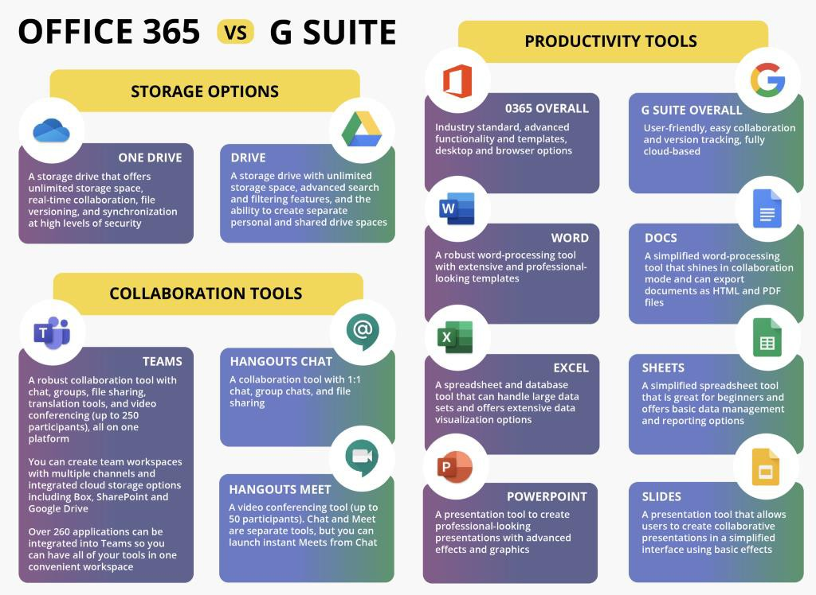

OFFICE 365 vs G SUITE

STORAGE OPTIONS

- ONE DRIVE: A storage drive that offers unlimited storage space, real-time collaboration, file versioning, and synchronization at high levels of security

- DRIVE: A storage drive with unlimited storage space. advanced search and filtering features, and the ability to create separate personal and shared drive spaces

COLLABORATION TOOLS

- TEAMS: A robust collaboration tool with chat, groups, file sharing, translation tools, and video conferencing (up to 250 participants) all on one platform

You can create team workspaces with multiple channels and integrated cloud storage options including Box, SharePoint and Google Drive

Over 260 applications can be integrated into Teams so you can have all of your tools in one convenient workspace

- HANGOUTS CHAT: A collaboration toot with 1:1 chat, group chats, and file sharing

- HANGOUTS MEET: A video conferencing tool (up to 50 participants), Chat and Meet are separate tools, but you can launch Instant Meets from Chat

PRODUCTIVITY TOOLS

- O365 OVERALL: Industry standard, advanced functionality and templates, desktop and browser options

- WORD: A robust word-processing tool with extensive and professional looking templates

- EXCEL: A spreadsheet and database tool that can handle large data sets and offers extensive data visualization options

- POWERPOINT: A presentation tool to create professional looking presentations with advanced effects and graphics

- G SUITE OVERALL: User-friendly, easy collaboration and version tracking, fully cloud-based

- DOCS: A simplified word-processing tool that shines in collaboration mode and can export documents as HTML and PDF files

- SHEETS: A simplified spreadsheet tool that is great for beginners and offers basic data management and repolling options

- SLIDES: A presentation tool that allows users to create collaborative presentations in a simplified interface using basic effects

