Summary Report
Institutional Equity and Diversity Committee Academic Year 2011-2012

Submitted to: Dr. Donald Birx Chancellor

Dr. David Christiansen Associate Dean for Academic Affairs

Dr. Dawn Blasko Chair, Faculty Council

Compiled by
Dr. Mary Beth Pinto (Chair) May, 2012

Table of Contents
Membership and Charges 3
Administrative Fellow Subcommittee 4
Climate Subcommittee 7
Diversity Subcommittee 9
Mentoring Subcommittee 11
Proposed Change in Membership 16

Committee Membership and Charges For the Academic Year 2011-2012
Chair: Mary Beth Pinto Members:
Catherine Bae Bill Baxter
David Christiansen Richard Englund Linda Hajec
Andy Herrera Kathy Holiday-Darr Michelle Previte Soledad Traverso Sarah Whitney

Based on the charges for this year, four subcommittees were formed: Administrative Fellow
Climate Diversity Mentoring

IEDC: Institutional Equity and Diversity Committee May, 2012 Administrative Fellow Subcommittee
Members: Richard Englund, Michelle Previte

Charge: Continue with the Charge from Academic Years 2009-10 and 2010-11 to attract strong candidates for Penn State Behrend’s Administrative Fellows Program who will be future academic leaders at our institution.

Summary of efforts to date:
The IEDC coordinated the efforts of the Administrative Fellows Application Process for 2010-2011. However, despite the concerted efforts by this committee to promote the program, it had only three applicants for the two positions in the last cycle.

After consulting with the rest of the IEDC committee, this subcommittee is making the following suggestions and revisions to its earlier suggestions for the future in order to increase the number of applicants to the Administrative Fellows Program.

- Alternate Years:
We continue to believe that it is wise to run the program in alternate years in order to build up demand. Thus, we expect to have the next cohort of Fellows serve during the 2013-14 academic year.

Incentives:
Clearly state the course release and/or reallocation of weights that the Fellows will receive. Typically, this is ½ time course release for faculty and ½ time work release for staff.

Timeline:
Originally, we made a timeline in which the process of assigning the Fellows spanned 2 semesters and the selection was made at the end of the fall semester of the year prior to service. This was an effort to address the possible deterrent for staff from applying because they may be hesitant to put a strain on those who are left to fill their duties while they are busy with the Fellowship. With input from the IEDC committee, we have shortened this timeline. Please see the chart below.

4. Obtain Proposals:
We believe that it is wise to seek proposals from faculty, staff, and administrators that outline what a Fellow will accomplish during his or her time of service. The proposal need not come from someone who plans to apply to become a Fellow. The thought here is that having these proposals would remove the ambiguity associated with the Fellows’ jobs and will instill excitement about what the Fellows can accomplish.

The question is, “What setting is best to elicit such proposals?” We suggest a “Meeting of the Minds” -- a lunchtime brainstorming session consisting of at least the following people: David Christiansen, each of the School directors, Ken Miller,
Mary-Ellen Madigan, Mary Beth McCarthy, and the past Administrative Fellows. We suggest that the directors consult with the faculty and/or staff under their leadership

for suggestions they may have and come to the meeting prepared to discuss these ideas as well as their own ideas. We propose “selling” the Administrative Fellows Program as a way for the directors to delegate some of their responsibilities to someone else, thus freeing up some of their time for their other duties.

5. Applicant Pool:
We believe that the applicant pool can be both widened and strengthened if the administration personally encouraged those who they think should apply. Often, people will not see themselves in such a position until they are given personal encouragement.

Below is a suggested timeline, followed by a mock proposal

Date | Activity Due
April, 2012 | Meeting of the Minds
August, 2012 | Follow-up mailing from Selection Committee to leadership requesting any additional proposals
September, 2012 | The Selection Committee matches proposals with supervisors.
September – October, 2012 | Publish the proposals and advertise that the Selection Committee is seeking applicants for the 2013-2014 Program year.
September – October, 2012 | The Selection Committee identifies possible candidates for the Program and personally encourages these people to apply to become Fellows.
November 1, 2012 | Applications due.
December 10, 2012 | Selection of Fellows.
August, 2013 | Fellows assume duties.

Administrative Fellowship Program – Sample Proposal

In the 2008-2009 through 2012-2013 strategic plan for the Behrend College, Goal 4 is Building a More Diverse and Supportive Campus Community. The first bullet in section 4F states: “The College will create the Behrend Administrative Fellowship Program to provide professional development opportunities for female and minority members of the faculty and staff”.

It is the context of the strategic plan that the following sample proposal for an administrative fellowship project is offered.
In support of the current College Strategic Plan, item 7.C.1, an Administrative Fellowship opportunity is available for an individual to work alongside current members of the College administration and with Harborcreek Township to improve pedestrian safety with respect to vehicular traffic on Jordan Road. The individual taking on this challenge should expect to have significant interaction with Operations, senior administrators, the Development office, and the Township during this fellowship. Areas of investigation will include legal/governmental issues which will limit options that the College might undertake, to include Americans with Disabilities Act compliance of each option to deal with this situation, and what options are acceptable to the Township and non-College users of the roadway. Several possible options have been identified, including closure of the College segment of the roadway, building a pedestrian overpass or a pedestrian tunnel beneath the roadway, or slowing traffic by addition of barriers, curbs, and planters. Currently there is no funding available for any college initiated changes to the roadway or crossing, so there can be significant effort to identify potential donors of private funding, or investigation of possible federal or state granting opportunities that may fund the proposed improvements. It is entirely possible that the major effort will be political in dealing with the township government. The Administrative Fellow will be the primary college person responsible for pursuit of these improvements.
It is expected that the individual entering this Administrative Fellowship will also have opportunity to attend meetings and participate alongside senior administrators in other activities, with the intent of broadening his or her administrative experience.
The Administrative Fellow will typically have release from usual responsibilities equal to 10 hours per week in the fall semester and 20 hours per week in the spring semester and following summer.

When proposals are written for possible fellowships, it is suggested that the goal of the fellowship be described, and the time available to accomplish the major task be spelled out as it is above. Many different significant projects could make an appropriate fellowship for the right candidate. While the above project might be appropriate for a political science or engineering faculty member, there are undoubtedly useful projects more appropriate to other participants.

IEDC: Institutional Equity and Diversity Committee May, 2012 Climate Subcommittee
Members: Soledad Traverso and Sarah Whitney

Charge: The subcommittee was assigned to analyze the results of the climate survey.

To review: The committee drafted the survey last year after reading similar surveys (including Penn State surveys) and discussing Behrend-specific issues. Drafts of the survey began to be submitted to the IEDC in November. The survey went through six rounds of editing for clarity and content in the period between November and March. Mentoring was removed as a category of inquiry (and sent to another subcommittee at their request), and many questions were re-phrased. The IEDC made suggestions about standardizing the scales used to assess responses.

In March, we asked Qi Dunsworth to code the survey in ANGEL. Five IEDC members piloted the survey in ANGEL and discovered several “glitches,” which we were able to remove.

The survey is over 100 questions long, and was open for comment during the period of April 4-April 18 2011. 130 full time faculty members and 11 part time faculty members responded to the survey. This exceeded the expectations of Qi Dunsworth.

We received the data over the summer. The demographic overview of the respondents is below:

- 76 (54.1%) respondents identified as male.

- 49 (34.7%) respondents identified as female.

- 16 (11.2%) respondents chose not to identify with a gender.

- 110 (78%) respondents identified as white.

- 24 (17%) respondents chose not to identify with a race.

- 7 (5%) respondents identified as African-American, Asian, or Hispanic/Latino.

Our subcommittee broke up the data into seven areas of concern. These areas were: Overall Climate Perceptions, Work Equity, Harassment/Negative Behaviors, Campus Safety, Classroom Issues, Existing Campus Resources, and Suggestions for Change.

Under each area, we discussed potential strategies for ameliorating problems and building on successes. We created objectives and action steps, using targeted data from the survey. The action steps are modeled after the Penn State Behrend Strategic and Diversity Plans in that they contain a projected timeline and a responsible office. We have done this both for the sake of document consistency and because assigning responsibility and having (at least a rough idea of) a timeline will help to ensure implementation of the suggestions.

The survey began to be discussed in committee in October 2011. We brought suggestions for all seven goals in staggered fashion (one meeting was devoted to discussing goals #1-2, etc.). The IEDC had many helpful suggestions, particularly in terms of adding support for international faculty.

Data was disaggregated by gender and race at specific points in the survey. We remained very concerned about the ability to inadvertently identify respondents, given the low demographic numbers of certain groups. When a problem needed to be addressed in the report, but the group raising it was small and potentially identifiable, number figures were not used.

The survey report will be completed at the year’s end, and released to the campus and to the Chancellor’s Office. We anticipate that faculty members will have additional suggestions and requests.

We hope that the suggestions in the survey are a good first step in improving areas of the climate that require everyone’s attention.

IEDC: Institutional Equity and Diversity Committee May, 2012 Diversity Subcommittee
Members: Catherine Bae, Linda Hajec, and Andy Herrera

Charge: To develop an effective approach to promote and inform campus about diversity issues.

The Diversity subcommittee met several times to discuss and develop an effective approach to promote and inform our campus community about diversity issues. The subcommittee concluded that a one-page information sheet to be placed at various locations across campus would provide an easy and practical way to achieve this goal—similar to the one distributed by the Health Center. The information sheet would include two to three bullet points with information related to specific areas of diversity, e.g., disability, race/ethnicity, sexual orientation, and gender, among others. The informational sheet will be organized in three parts: 1) Topic, 2) Best Practice(s), and 3) a Campus Voice—a statement by a student, faculty or staff member related to the topic discussed.

Several drafts were developed. After feedback from various individuals, the final draft was submitted to the Copy and Multimedia Center’s graphic designer for final development. Once completed, the informational sheets will be distributed across “key locations” on
campus. The subcommittee’s goal is to begin distribution of this information by FA12.

The subcommittee is also considering other methods to enhance the dissemination of this information. Some of these include using an RSS feed and linking the newsletter to a website.

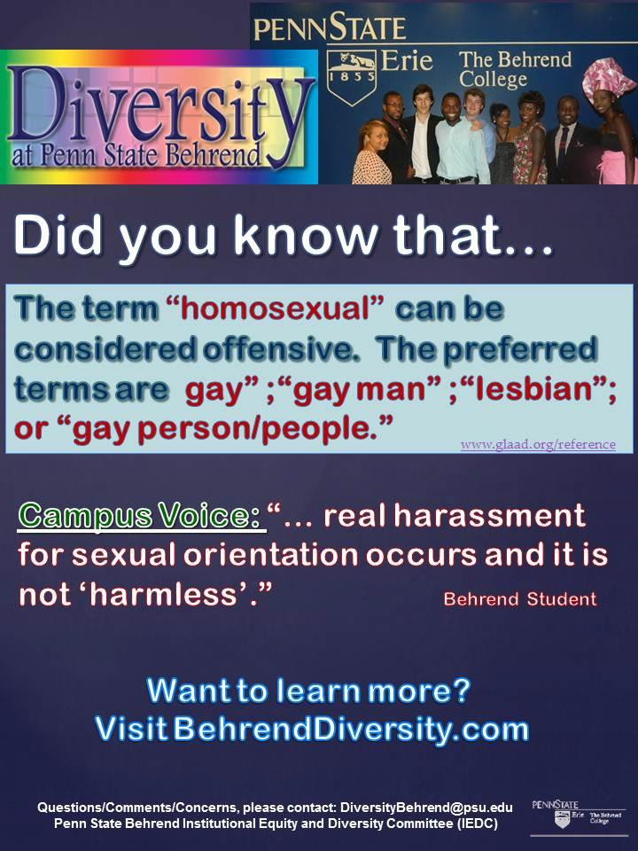

IEDC: Institutional Equity and Diversity Committee May, 2012 Mentoring Subcommittee
Members: Bill Baxter, Kathy Holiday-Darr, MB Pinto

Charge: To design a mentoring survey for assessing faculty perceptions of mentoring on campus and analyze the survey results12

The mentoring survey was launched on February 2, 2012, with a reminder sent on February 13, 2012. It was sent to all full-time faculty (Tenure track – full, associate, and assistant level) and fixed term faculty (FTM and FT1).

Please see the table below for descriptions of response rate and sample composition.

Category | Number
Invites: | 245
Visits: | 175
Completes: | 129
Response Rate: | 53%
SOB | 22 (17%)
SOE | 19 (15%)
SHSS | 41 (32%)
SOS | 32 (25%)
No Answer | 14 (11%)
TT (Full or Associate) | 42 (33%)
FTM | 35 (27%)
FT1 | 16 (12%)
Part Time | 0
No Answer | 15 (12%)
Males | 64 (50%)
Females | 48 (38%)
No Answer | 15 (12%)
Color/Multi-racial | 11 (9%)
White | 97 (76%)
No Answer | 20 (16%)

¹ The mentoring survey design began in 2010-2011 after the subcommittee studied the mentoring policies of the four schools at Penn State Erie.
2 Special thanks to Andrew Watters and the Institutional Research Committee for their assistance with inputting the survey into Zoomerang and helping with the data analysis.

Two types of mentoring were assessed on campus: Official (Appointed Mentors) and Unofficial Mentors.

Official Mentor3

Respondents were asked: Have you been appointed a mentor in the last 5 years?
33% (n=43) Yes; 67% (n=86) No
Of those that had an appointed mentor:
- From their school (98%)
- Initiated contact first semester (93%)
- Had 3 or more meetings/year (75%)

Tenure-Track (Assistant) 57% (n=15/20) Yes; 25% (n=5/20) No Fixed Term (Multi) 29% (n=10/35) Yes; 71% (n=25/35) No
Fixed Term One Year 69% (n=11/16) Yes; 31% (n=5/20) No

Unofficial Mentor4

Respondents were asked: Did you seek help of an unofficial mentor in the last 5 years?
55% (n=71) Yes; 45% (n=58) No
Men 41% (n=26/64) Yes
Women 69% (n=33/48) Yes

(*Significant difference between men and women seeking help from unofficial mentor.) Number of unofficial mentors:
• 1 (32%)
• 2 (34%)
• 3 (17%)
• >3 (17%)

Of those that had an unofficial mentor(s):
- From their school (62%)
- Unofficial mentor approached them (6%)
- Respondent sought out the unofficial mentor (63%)
- Both ways for establishing relationship (31%)
- 3 or more meetings/year (58%); Only 2 meetings/year (25%)

3 See Table 1 for information on Types of Help Sought from Official Mentor
4 See Table 2 for information on Types of Help Sought from Unofficial Mentor

Both official and unofficial mentoring at Penn State Behrend appears to be important and should be continued.

Overall Satisfaction: (Scale 1-5 (SDA = 1; SA = 5)
Positive experience overall with Official Mentoring: mean 4.09, 71% - 4 or 5
Positive experience overall with Unofficial Mentoring: mean 4.49, 75% - 4 or 5

Future Suggestions: Official Mentoring:
- Suggestion #1: Assign an official mentor to all incoming faculty, including part-time.
- Suggestion #2: Allow the new faculty member the opportunity to select an official mentor.

  - Factors that were deemed important were: Knowing the mentor on a personal level, being from the same school, the mentor having a positive outlook and the time to be a mentor.
  - Factors that were not deemed important were: Being the same cultural background, gender, age and rank.

Concern Noted: Some faculty indicated that they were not aware of an official mentoring program on campus. (Open ended-comments)

Unofficial Mentoring:

- Suggestion #1: Unofficial mentor receives credit for helping ‘new’ faculty so that there is more of an incentive to help.

Table 1: Types of Help Sought from Official Mentor (# of people with official mentors, n= 43)

Area | Seek Help? Yes/No | If Yes, how helpful?  1= Not at all  5= Very Helpful
TEACHING | YES | Mean
Requirements for teaching | 69% (29) | 3.97
Syllabus prep | 64% (27) | 4.0
Classroom management | 63% (27) | 4.09
Students active learning | 53% (23) | 3.97
Exams and grade fairness | 55% (25) | 3.97
Team projects | 38% (16) | 3.88
Classroom participation | 55% (25) | 4.03
Cheating | 52% (22) | 3.92
Attitude toward students | 45% (19) | 3.92
Difficult students | 60% (26) | 3.94
RESEARCH
Requirement for research | 60% (25) | 4.06
Research plan and time management | 43% (18) | 3.76
Data processing and methodology | 15% (6) | 3.41
Journals and submissions | 15% (6) | 3.59
Revising and responding to journal editors | 8% (3) | 3.62
Paper editing | 15% (6) | 3.53
Co-authoring | 17% (7) | 3.56
SERVICE
Requirements for service | 60% (26) | 1.51
Service plan and time management | 53% (23) | 1.63
Outreach | 39% 916) | 1.76
Committee work | 63% (26) | 1.44

Table 2: Types of Help Sought from Unofficial Mentor (# of people with unofficial mentors, n = 71)

Area | Seek Help? Yes/No | If Yes, how helpful?  1= Not at all  5= Very Helpful
TEACHING | YES | Mean
Requirements for teaching | 60% (41) | 4.25
Syllabus prep | 39% (26) | 3.92
Classroom management | 62% (40) | 4.16
Students active learning | 46% (30) | 3.97
Exams and grade fairness | 58% (38) | 4.02
Team projects | 39% (25) | 3.85
Classroom participation | 42% (28) | 3.97
Cheating | 47% (30) | 4.03
Attitude toward students | 33% (21) | 3.97
Difficult students | 63% (41) | 4.29
RESEARCH
Requirement for research | 48% (32) | 4.27
Research plan and time management | 34% (22) | 3.71
Data processing and methodology | 14% (9) | 3.33
Journals and submissions | 20% (13) | 3.95
Revising and responding to journal editors | 31% (20) | 3.88
Paper editing | 25% (16) | 3.87
Co-authoring | 29% (19) | 3.84
SERVICE
Requirements for service | 53% (35) | 1.62
Service plan and time management | 29% (19) | 1.85
Outreach | 23% (15) | 1.91
Committee work | 54% (35) | 1.57

IEDC: Institutional Equity and Diversity Committee May, 2012 Proposed Membership Change

Proposal: It is the belief of the Institutional Equity and Diversity Committee (IEDC) that the composition of the committee is not a good representation of Behrend College. To ensure that faculty, student, and staff perspectives are voiced through this committee, we would like to propose a change in the committee’s membership for the 2012-2013 academic year. This change will not create a regular standing committee of Faculty Senate and will not require a change in the PSB faculty constitution.

8 Faculty members (two appointed from each school)
2 Students - from the Multi-Cultural Council and SGA Diversity Committee 1 Individual from Educational Equity (Andy Herrara) – Ex Officio
1 Individual from the Chancellor’s office (Dr. Christiansen) – Ex Officio 1 Individual from Women’s Liaison Committee (Member) – Ex Officio
4 Staff members (selected from different areas, such as: 1 academic, 1 other area [CMC, Development, and CE], etc.)
Total 17 members: 14 voting members and 3 Ex Officio Members Specifics:
- Chair of IEDC will be appointed by Dr. Birx and the incoming Chair of Faculty Council – from the 8 faculty and 4 staff on the committee.
- All faculty and staff will be appointed by Dr. Birx and the incoming Chair of Faculty Council.
- All appointments will be 2 year, staggered appointments to allow for continuity of membership.
- Effective Fall 2012.

