Penn State Behrend
Using Drupal to Edit Your Web Site
August 2013

Alternative Format Statement
This publication is available in alternative media upon request.

Statement of Non-Discrimination
The Pennsylvania State University is committed to the policy that all persons shall have equal access to programs, facilities, admission, and employment without regard to personal characteristics not related to ability, performance, or qualifications as determined by University policy or by state or federal authorities. It is the policy of the University to maintain an academic and work environment free of discrimination, including harassment. The Pennsylvania State University prohibits discrimination and harassment against any person because of age, ancestry, color, disability or handicap, national origin, race, religious creed, sex, sexual orientation, or veteran status. Discrimination or harassment against faculty, staff, or students will not be tolerated at The Pennsylvania State University. Direct all inquiries regarding the nondiscrimination policy to the Affirmative Action Director, The Pennsylvania State University, 328 Boucke Building, University Park, PA 16802-5901; Tel 814-865-4700/V, 814-863-1150/TTY.

Permission to copy all or part of this document is granted provided that the copies are not made or distributed for direct commercial advantage. In addition, any duplicated materials must be attributed to the Penn State Behrend Computer Center and include this credit notice. Direct any questions or requests to:
Carolyn Dudas
Penn State Behrend
Computer Center
4205 College Drive
Erie, PA 16563-1201
814-898-6458
ddz@psu.edu

Table of Contents
Login to Drupal 1
Logout of Drupal 1
Drupal Menus 1
Overview of the Dashboard 2
Access the Dashboard 2
View Pages that are Published 2
View Pages that are Pending Approval 2
View Pages that are Unpublished 2
View or Edit a Page from the Dashboard 3
Sort the Columns on the Dashboard 3
Search the Dashboard 3
Search for a Page 3
Overview of the Tabs 4
Overview of the Editing Toolbar 5
Create, Save, and Publish a New Page 6
Edit and Save an Existing Page 8
Close a Page (without saving) 9
Preview a Page 9
Delete a Page 9
Unpublish a Page 10
Republish a Page 10
Select a Template for a Page 11
Using Spell Check 11
Paste Text from Another Application 11
Create a Link to a Page within Your Site 12
Create a Link to a Page Outside Your Site 13
Create an Anchor 14
Create a Link to an Anchor 14
Remove an Anchor 14
Create an Email Link 15
Link to an Existing File 16
Upload and Link to a File 17
Remove a Link 18
Upload and Insert a New Image 19
Insert an Existing Image 22
Resize an Image 24
Create a Table 25
Modify a Table 27
Delete a Table 27
Add Items to Right Sidebar (i.e Information Box) 28
Add an Item to the Navigation Menu 29
Create a News Article 30
Create an Event 33

Login to Drupal
- Open a new web browser session.
Firefox works best. Other browsers work except when using the LinkIt button.
- Navigate to http://psbehrend.psu.edu (or any page within the college web site).
- Scroll down to the bottom of the page and click on the link: Login.
- Login at the Penn State WebAccess screen.
The dashboard is displayed which lists the pages on your site.

Logout of Drupal
- At the top (right corner) of the page, click on the link: Logout.
- Exit from the web browser.

Drupal Menus
There are two menu bars at the top of the screen. The first one is the primary menu; underneath this one is the secondary menu. The menu items in the secondary menu will change depending upon the item you select from the primary menu.

Example of the menu bar after logging in:
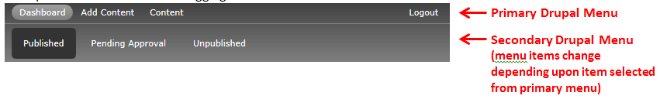
Primary Menu Items
- Dashboard – Displays a list of all the pages within your site. Or, you can choose to view a list of only those pages that are pending approval or that are unpublished.
- Add Content – Allows you to create a new page, news item, or event item.
- Content – Displays a list of all the pages within your site. This view allows you to quickly search for pages, news, and events

Overview of the Dashboard
The dashboard provides a list of all pages that you are responsible for editing. You can view pages that are published, unpublished, or pending approval.

Access the Dashboard
- From the primary Drupal menu, click on Dashboard.
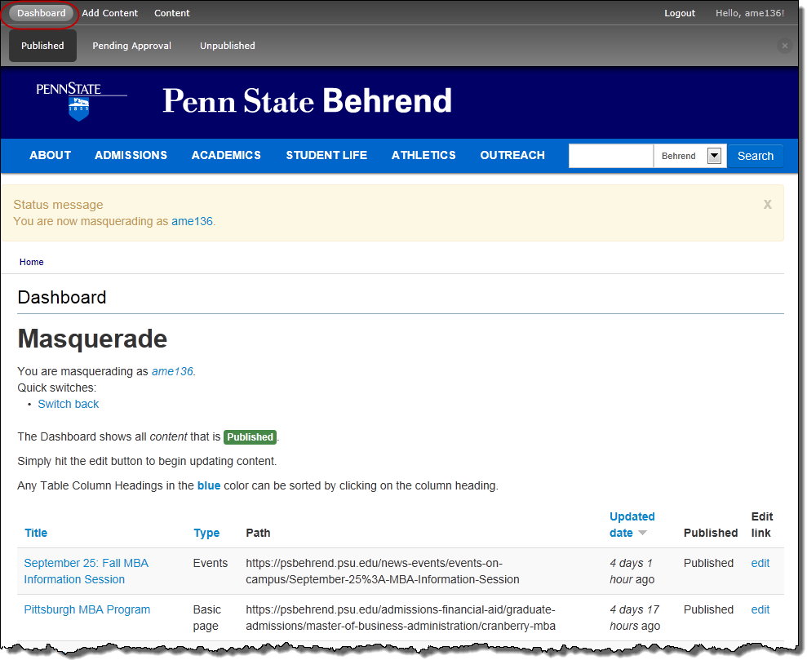

View Pages that are Published
- From the primary Drupal menu, click on Dashboard.
- From the secondary Drupal menu, click on Published.
A list of published pages appears. These are pages that can be viewed by the public.

View Pages that are Pending Approval
- From the primary Drupal menu, click on Dashboard.
- From the secondary Drupal menu, click on Pending Approval.
A list of pages that are awaiting approval is displayed.

View Pages that are Unpublished
- From the primary Drupal menu, click on Dashboard.
- From the secondary Drupal menu, click on Unpublished.
A list of pages that are unpublished is displayed. These are pages that are not viewable by the public.

View or Edit a Page from the Dashboard
- To view a page, click on the page title in the Dashboard.
Once you are in this view, you can also click the Edit tab to edit the page.
OR
To edit a page, click on the edit link (in the last column) that corresponds to the page you wish to edit.
This will automatically open up the page in editing view.

Sort the Columns on the Dashboard
You can sort each column on the Dashboard in ascending or descending order.

To sort the items:
- Click on a column’s title.

Search the Dashboard
The search feature will be available at a later date.
The dashboard allows you to search for a page by title, content type (i.e. a basic page, news article, event, etc.), or by its publishing state.

Search for a Page
The search feature will be available at a later date.
- In the Title box, type a word that appears in the title of the page.
- At the Type box, select the type of page: Any, Basic Page, News, or Event.
- Click the Apply button.

Overview of the Tabs
Once you navigate to a page, you will see the following tabs:
- View – Provides an approximation of what your page will look like when viewed by a visitor. This is selected by default.
- Edit – Allows you to edit a page. Select this tab if you wish to edit the page.
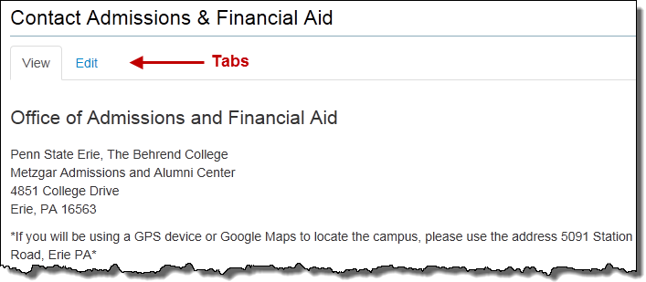

Overview of the Editing Toolbar
The toolbar is very similar to toolbars that you see in other applications.

The icon and name of each button is shown below.

Templates (to be available at a later date)
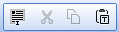 Select All, Cut, Copy, Paste as Plain Text
Undo, Redo, Spell Check, Find, Replace
Styles ??? --- H1 (page title) and H3 (heading) are too similar in size (160%, 150%). No style for body text (to change from a heading back to body text).
Bold, Italic, Strikethrough, Subscript, Superscript, Remove Format
Special Character
Left Align, Center, Right Align
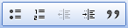 Bullet List, Numbered Bullets, Outdent, Indent, Block Quote
Link, LinkIt Plus, Unlink, Anchor
Image, Horizontal Rule, Table
Source
Maximize

Create, Save, and Publish a New Page
When you create a new page, you will see the following screen with these components:
- Close button: Located at the top, right corner of the screen.
- Approval Message: Reminder that a new page won’t be made public until it has been approved.
- Save button: Located at the top and bottom of the screen.
- Title box: Used for the title of the web page.
- Body/Content area: The location where you place the content for your page. (For more information about the toolbar, refer to the previous section.)
- Resize button: Used to resize the body/content area.
- Behrend Section: Indicates which section this page belongs to.
- Status: Indicates current status of page.

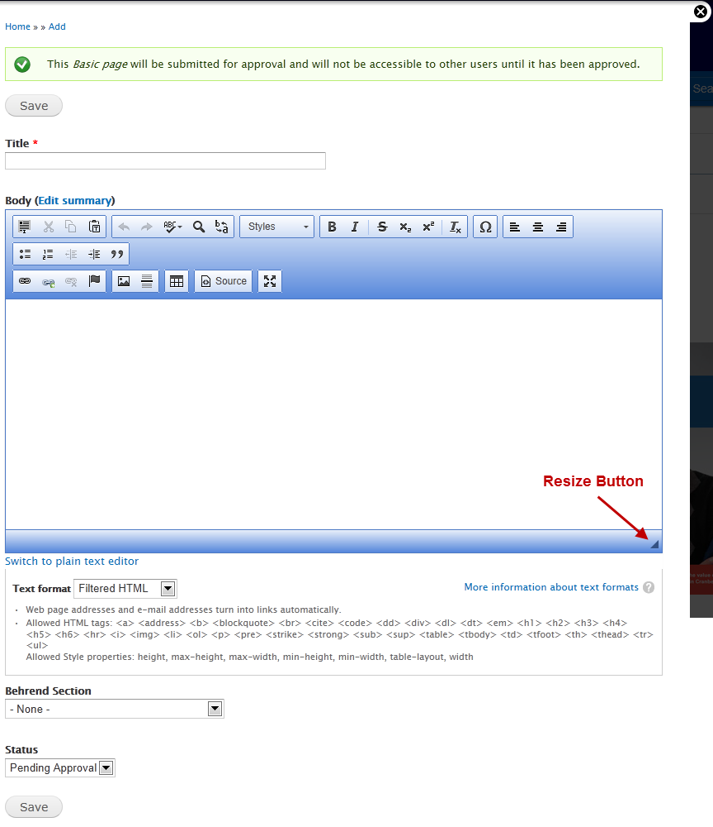
To create and save a new page:
- From the primary menu, select: Add Content.
- From the secondary menu, select: Page.
- In the Title box, type a title for the web page.
Remember: The title is part of the web page address, so keep it brief, but meaningful.
- Click in the body area and enter your content.
- For the Behrend Section, select the appropriate section for the location of the new page.
- Click the Save button.
The button is located at the top and bottom of the editing screen.
The page is submitted for review. Once approved, you will be notified via email and the page will appear on your dashboard. The page is available to the public once you create a link to it.

Edit and Save an Existing Page
- Navigate to the page that you wish to edit.
- Click the Edit tab.
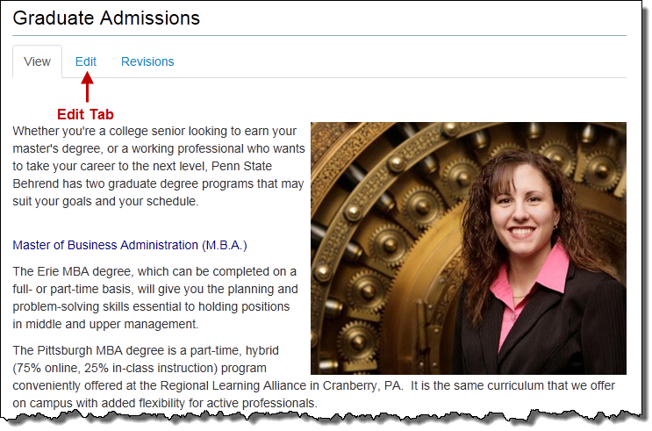
- Make the desired changes to the page.
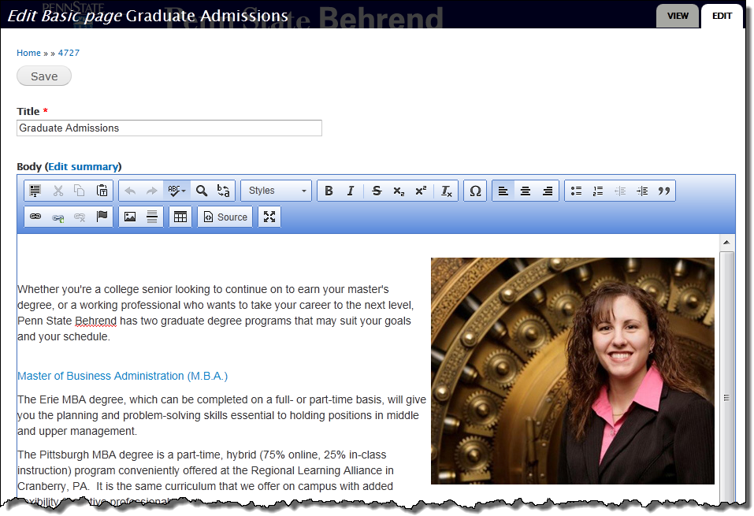
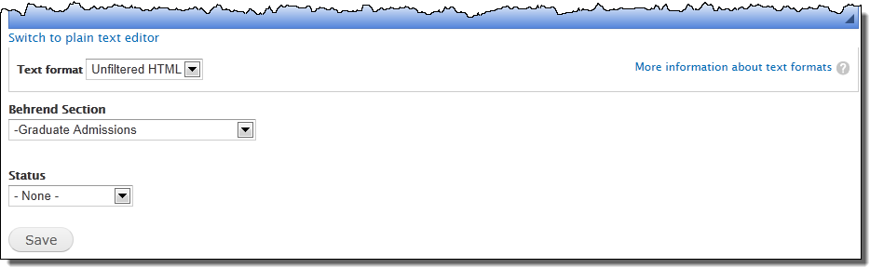
- Click the Save button.

Close a Page (without saving)
To close a page without saving any changes:
- Click the Close button.
The button looks like this: (a black circle with an “X”). It is located at the top, right side of the editing screen.

Preview a Page
The preview provides an approximation of what the page will look like when viewed by a web site visitor.

To preview a page:
- If needed, save or close an opened page.
The page is now in view mode.
OR
Click on the View tab.

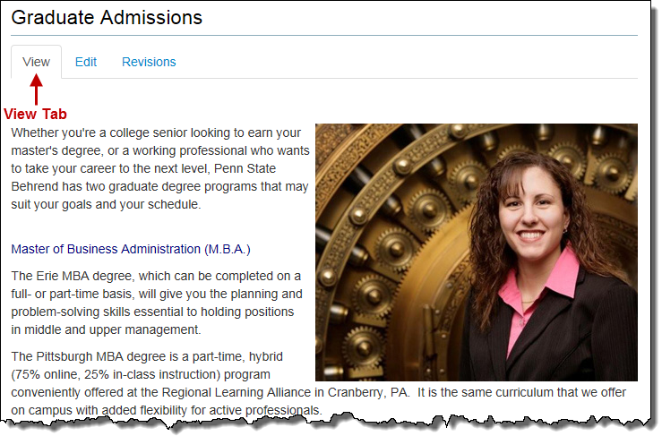

Delete a Page
- Click the Edit tab for the page you wish to delete.
- Scroll down to the lower half of the page and click the drop-down arrow for the Status field.
- Select Delete.
- Click the Save button.
Important: The page is permanently deleted.

Unpublish a Page
If you no longer wish a page to be available to the public for viewing, you can unpublish the page. (The page is not deleted; it’s just that it can’t be viewed by the public.)

- Click the Edit tab for the page you wish to unpublish.
- Scroll down to the lower half of the page and click the drop-down arrow for the Status field.
- Select Unpublish.
- Click the Save button.
When you unpublish a page, it will be removed it from the left navigation menu (if it had originally appeared there).
Although a page may be unpublished, it still appears in the dashboard. To see your unpublished pages, go to the Dashboard and click on Unpublished.
You can locate the page on the dashboard by searching for the page title or by the published state. ??? --- Not working; unpublished page doesn’t appear in dashboard.
If you decide that you want to publish this page at a later date, you will need to re-publish the page.

Republish a Page
If a page has been unpublished (i.e. is not available for public viewing), you can choose to re-publish the page making it available to the public.

- Click the Edit tab for the page you wish to republish.
- Scroll down to the lower half of the page and click the drop-down arrow for the Status field.
- Select Republish.
- Click the Save button.

Select a Template for a Page
This feature will be available at a later date.

- Click the Template button.
- Select one of the following templates: Two Columns, Text and Left Side Image, Text and Right Side Image, or One Column.
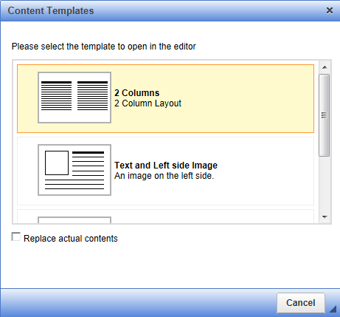
Placeholder text is inserted into the page.

- Replace the placeholder text with your content.

Using Spell Check
The spell check feature works very similar to those checkers found in Microsoft Word and in other applications. The spell checker automatically places a red squiggle under the word that is misspelled.

To spell check:
- Right mouse click on the misspelled word.
- From the pop-up menu, select the correct spelling or choose Ignore.
OR
Click the Spell Check button and then select Check Spelling.

Paste Text from Another Application
- Copy the text from another document (such as Word, etc.).
- Click in the location where you want to paste the text.
- Press Ctrl-V.
OR
Click the Paste as Plain text button.
- If you receive the prompt, “Do you want to allow this web page to access your clipboard?”, click the Allow Access button.

Create a Link to a Page within Your Site
- Select the text or image for which you want to create a link.
- Click the LinkIt+ button.
- In the Search Content dialog box, type the word(s) associated with the page you want to link to.
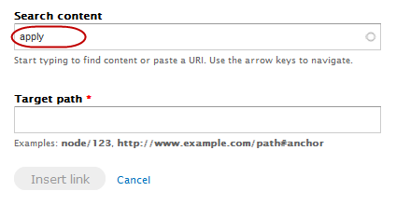
- From the list of results, click on the page that you wish to link to.
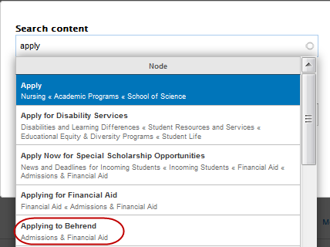
OR
If the desired page does not appear in the list…
  - Click outside the Search Content dialog box.
  - Open another tab within your web browser and browse to the page you want to link to.
  - Copy the web address.
  - Return to the Search Content dialog box.
  - Paste the web address into the Target Path box.
- Click the Insert Link button.

Create a Link to a Page Outside Your Site
- Select the text or image for which you want to create a link.
- Click the Link button.
- For the Link Type, select URL.
- In the URL box, type or paste the complete web address.
If you paste the complete web address, it will automatically select the correct prefix of http:// or https:// in the Protocol box.
If you type the web address without the prefix of http:// or https://, you will need to select the correct protocol.
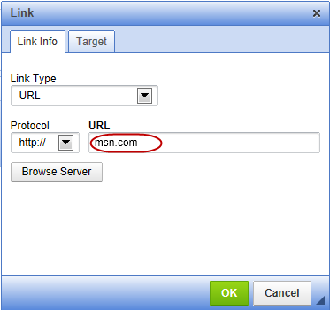
- Click OK.

Create an Anchor
An anchor is used with a link; it allows you to jump to a specific location within the same page. You must create the anchor first before you create the link.

- Select the text or image for which you want to create an anchor.
- Click the Anchor button.
The Anchor button looks like a flag.
- At the Anchor Properties dialog box… Type the name of the anchor.
Do not use spaces or special characters within the anchor name. Exception: You can use a hyphen.
Use title case for anchors consisting of several “words”. Example: MoreInfo
- Click OK.

Create a Link to an Anchor
- Select the text or image for which you want to create a link.
- Click the Link button.
- At the Link dialog box… Click the drop-down arrow for Link Type and select: Link to an Anchor in the Text.
- Click the drop-down arrow for By Anchor Name and select the desired anchor.
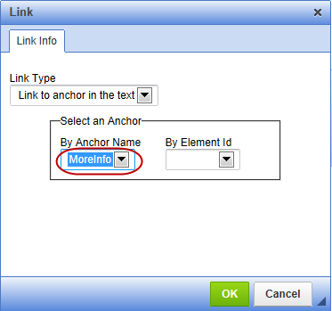
- Click OK.

Remove an Anchor
- Right mouse click on the text that contains an anchor.
- From the short-cut menu, select: Remove Anchor.

Create an Email Link
- Select the text or image for which you want to create an email link.
- Click the Link button.
- At the Link dialog box… Click the drop-down arrow for Link Type and select: Email.
- In the Email Address box, type the complete email address.
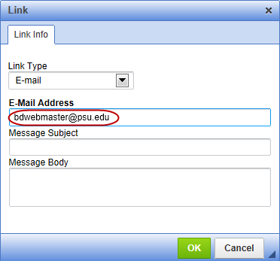
- Optional: Type in the subject of the message in the Message Subject box.
- Optional: Type the text of the message in the Message Body box.
- Click OK.

Link to an Existing File
File types that are acceptable for use on the college’s web site include: .doc, .docx, .gif, .jpg, .pdf, .png, .ppt, and pptx. File sizes should not exceed 6 MB.

- Select the text that you wish to use as the link to the file.
- Click the Link button.
- At the Link dialog box… Click the Browse Server button.
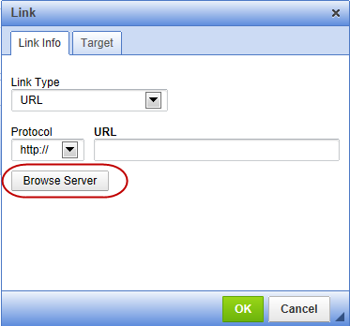
- At the File Browser screen… Navigate to and open the folder that contains the file you wish to link to.
- Click on the file that you wish to link to.
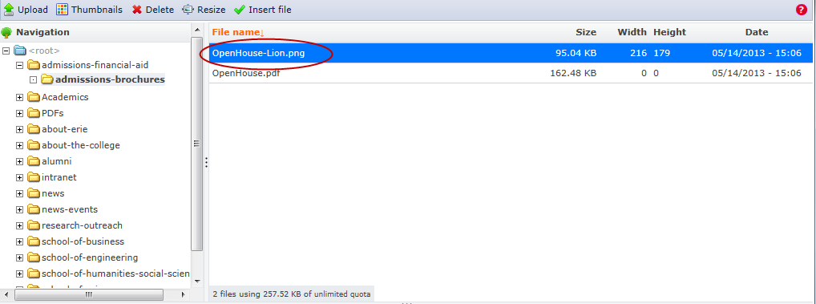
- Click the Insert File button.
- Click OK.

Upload and Link to a File
File types that are acceptable for use on the college’s web site include: .doc, .docx, .gif, .jpg, .pdf, .png, .ppt, and pptx. File sizes should not exceed 6 MB.

- Select the text that you wish to use as the link to the file.
- Click the Link button.
- At the Link dialog box… Click the Browse Server button.
- At the File Browser screen… Navigate to the folder where you want to upload the file.
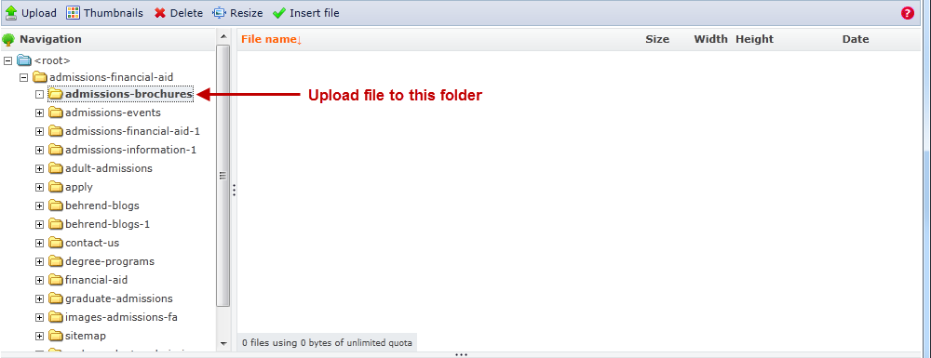
- Click the Upload button (located at the top of the screen).
- At the File Upload dialog box… Click the Browse button.
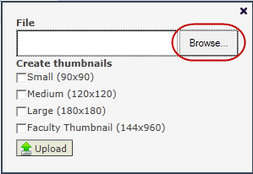
- Navigate to the folder on your PC that contains the file you wish to link to.
- Click on the file name that you wish to upload.
- Click the Open button.
- At the File Upload dialog box… Click the Upload button (located at the bottom of the screen).
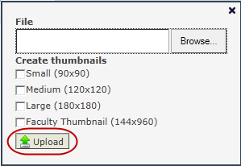

-continued-
- After the file has been uploaded, close the File Upload screen.
You will now see the list of files that have been uploaded to this area.
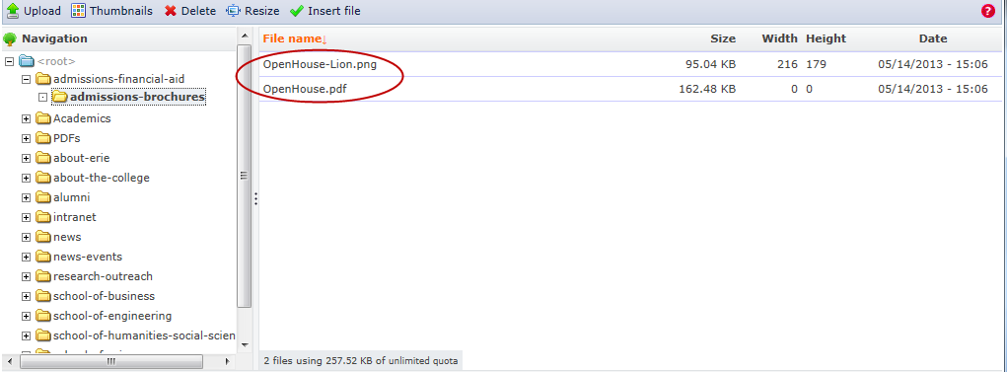

- At the File Browser screen… Click on the file that you want to link to.
- At the File Browser screen… Click the Insert File button (located at the top of the screen).
- At the Link dialog box… Click OK.

Remove a Link
- Select the linked text or image.
- Click the Unlink button.

Upload and Insert a New Image
Image types that are acceptable for use on the college’s web site include: .gif, .jpg, .jpeg, and .png. File sizes should not exceed 6 MB.

- Click in the location where you want to insert an image.
- Click the Image button.
- Click the Image Info tab (selected by default).
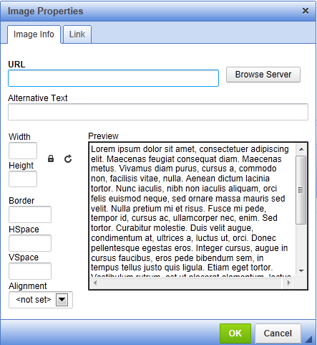
- Click the Browse Server button.
- At the File Browser screen… Navigate to and open the folder where you want to upload the image to.
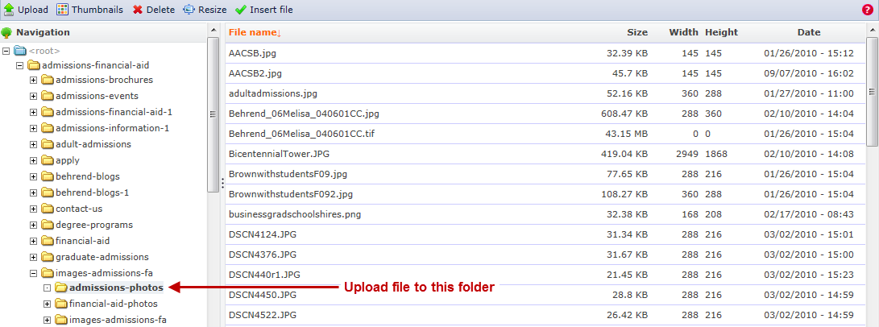
- Click the Upload button (located at the top of the screen).

-continued-
- At the File Upload dialog box… Click the Browse button.
- Navigate to the folder on your PC that contains the image you wish to upload.
- Click on the file name of the image.
- Click the Open button.
- At the File Upload dialog box… Click the Upload button (located at the bottom of the screen).
- After the file has been uploaded, close the File dialog box.
You will now see the list of files that have been uploaded to this area.
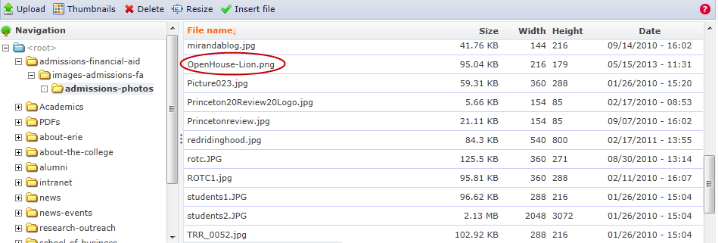
- Click on the name of the file that you want to insert.
If needed, resize the image. See the section, Resize an Image, for instructions.
- Click the Insert File button (located at the top of the screen).

- At the Image Properties dialog box… In the Alternative Text box, enter a description that explains the purpose or content of that image.
People who are blind use screen readers to read the text aloud. When a screen reader encounters an image, it will read the alt text to the person.
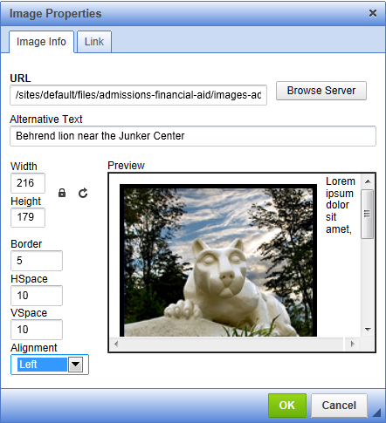
- If desired, you can format the image with a border or add horizontal and vertical spacing.
  - To do so, enter a number in the appropriate box(es).
- Select an alignment (i.e. left or right).
- Click OK.

Insert an Existing Image
- Click in the location where you want to insert an image.
- Click the Image button.
- Click the Image Info tab (selected by default).
- Click the Browse Server button.
- At the File Browser screen… Navigate to and open the folder that contains the image you wish to insert.
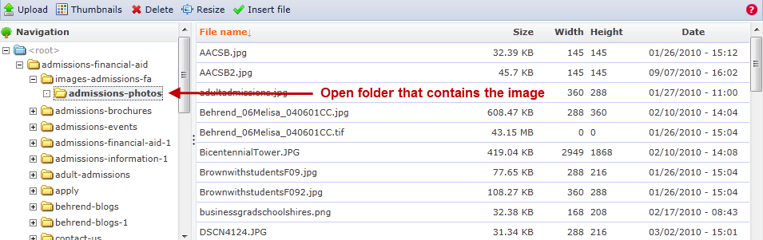
- Click on the name of the file that you want to insert.
- If needed, resize the image.
See the section, Resize an Image, for instructions.
- Click the Insert File button (located at the top of the screen).
- At the Image Properties dialog box… In the Alternative Text box, enter a description that explains the purpose or content of that image.
People who are blind use screen readers to read the text aloud. When a screen reader encounters an image, it will read the alt text to the person.
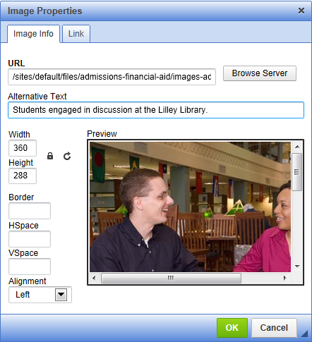
- If desired, you can format the image with a border or add horizontal and vertical spacing.
  - To do so, enter a number in the appropriate box(es).
- Select an alignment (i.e. left or right).
- Click OK.

Resize an Image
You can resize an image several different ways. ??? --- Should they be able to resize an image to any dimension? Editors can do this via Resize menu. Need to add a larger size (360x240) to Thumbnails menu.

These instructions assume that:
- the image has already been uploaded to the desired folder
- you are at the File Browser screen

To resize an image using predefined sizes:
- At the File Browser screen… Click on the image you wish to resize.
- Click the Thumbnails button.
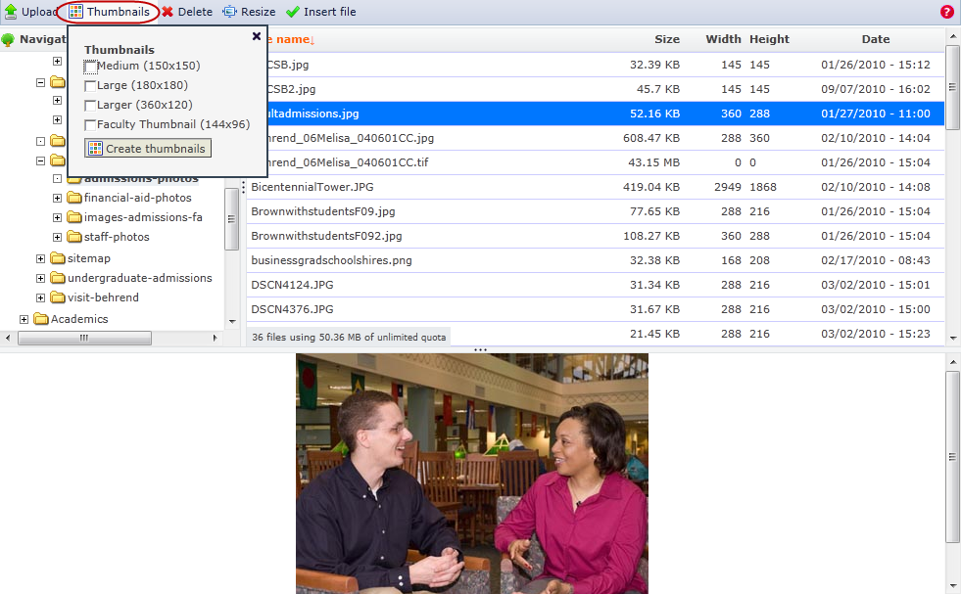
- From the Thumbnails menu, select the appropriate size.
- Click the Create Thumbnails button.
The newly created image will have a prefix added to the file name. The prefix corresponds to the image size you selected. Example: medium_adultadmissions.jpg
- Close the Thumbnails dialog box.

Create a Table
Tables should only be used if absolutely needed, such as a table which is presenting data. Further, if you use a table, be sure to include headers, a caption, and a summary. Tables should NOT be used to format content on a page.

The example below illustrates a very simple table. Generally, you would not use a table for information as simplistic as this.
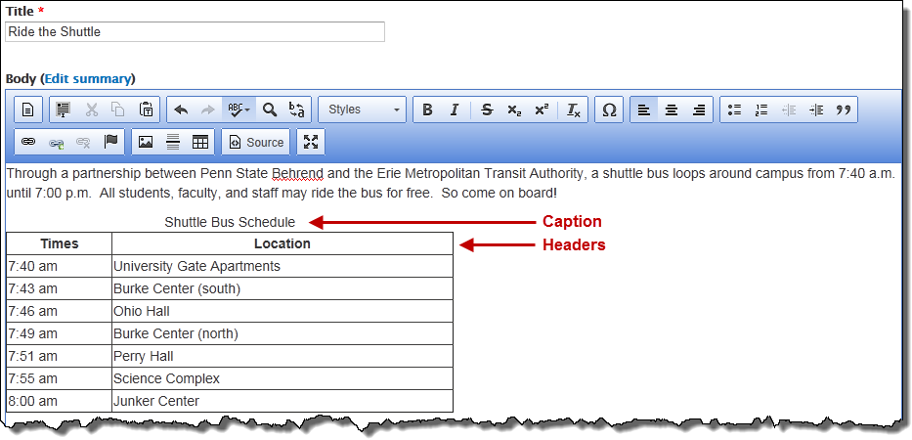

To create a table:
- Click in the location where you want to insert a table.
- Click the Table button.
- Type the desired number of rows into the Rows box.
- Type the desired number of columns into the Columns box.
- At the Headers box, select the appropriate header.
The header identifies whether a row and/or column contains a heading name.
- In the Border Size box, type a number to indicate the thickness of the border.
For no border, type a zero.
- At the Alignment box, select the appropriate alignment.
- In the Width box, type the desired table width (in percentage). Add a percent sign immediately after the number.
Example: 50%
- Optional: In the Height box, type the desired table height.
- In the Cell Spacing box, type the desired cell spacing (in pixels).
Cell spacing refers to the space between cells.
- In the Cell Padding box, type the desired cell padding (in pixels).
Cell padding refers to the margins within the cell.
- In the Caption box, type a brief caption for the table.
A caption is a title for the table.
- In the Summary box, type a summary that describes the organization of the table.
The summary is not displayed visually, but is used by a screen reader. A screen reader is used by a blind person to read the information out loud.
The summary provides a brief overview of how data has been organized into a table or an explanation of how to navigate the table.
Example: The first column contains the pick-up/drop-off times for the shuttle bus. The second column lists the locations for the shuttle bus stops.
The summary should not duplicate the caption.
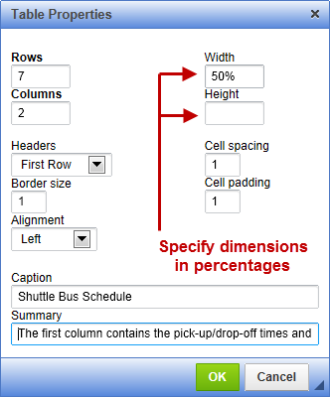
- Click OK.

Modify a Table
- Right-click in the table.
- From the short-cut menu, select one of the following:
  - Cell and then choose one of the desired actions:
    - Insert Cell Before, Insert Cell After, Delete Cells, merge Cells, Merge Right, Merge Down, Split Cell Horizontally, Split Cell Vertically
  - Row and then choose one of the desired actions:
    - Insert Row Before, Insert Row After, Delete Rows
  - Column and then choose one of the desired actions:
    - Insert Column Before, Insert Column After, Delete Columns
  - Table Properties and then edit the desired table properties.

Delete a Table
- Right-click in the table.
- From the short-cut menu, select: Delete Table.

Add Items to Right Sidebar (i.e Information Box)
Typically, the right side bar contains links to news, events, and to other information. The sidebar is populated automatically by items which have been designated (i.e. flagged) to appear in this area.

To flag a news item so that it appears in a sidebar: Refer to the section, Create a News Article.

To flag an event item so that it appears in a sidebar: Refer to the section, Create an Event.

Add an Item to the Navigation Menu
The navigation menu (i.e. the left nav) includes the main menu and submenus for your section. Each of these menu groups are limited to 8 to 10 links. To stay within these parameters, please create links within the content of the site. Also, depending upon the item, it may be appropriate to include the item in your section’s sidebar rather than as a menu item.
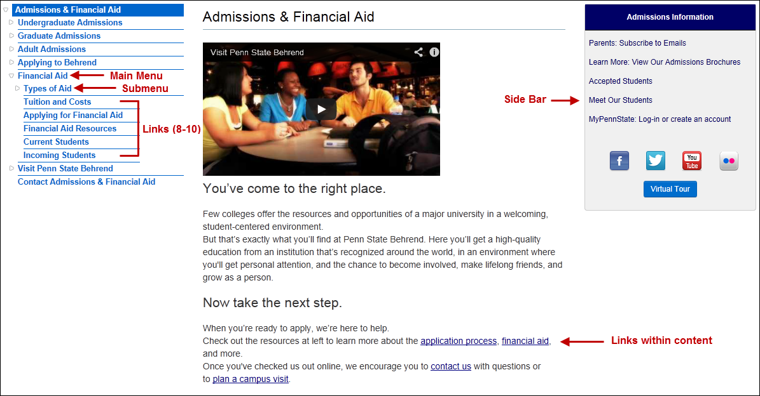
If you think a menu item is warranted for the left nav, please make a request by sending an email message to bdwebmaster@psu.edu. Please provide the following information:
- Section where the menu item is to be located
- Title for the menu item
- URL of the page that the menu item is to link to
Once received, it will be reviewed to determine whether the request for a new menu item can be accommodated.

Create a News Article
News articles are for announcements, office/departmental news, etc. that you wish to appear in the right sidebar of a section. Unlike pages, news items give you the ability to add a caption to a photo and will automatically add a “Posted on” date at the top of the page.

News articles will be automatically submitted to the Office of Marketing Communication. Once received, they will also be considered for possible inclusion in the news section of the Penn State Behrend home page. Note: If a news item is chosen to appear on the home page, OMC may need to edit or add additional information to the news item so that it aligns with the standard college news format.

- From the primary Drupal menu, select: Add content.
- From the secondary Drupal menu, click on News.
- In the Title box, type the headline for the news item.
- In the content section, enter the desired content.
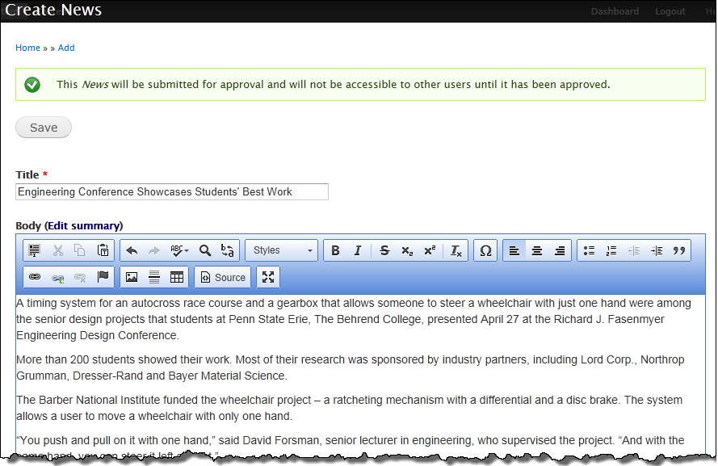
- If desired, insert a photo using one of the methods below.
Files must be less than 2 MB with dimensions not exceeding 480 x 320 pixels. If the image dimensions are larger, then image will be automatically resized to 480 x 320 pixels.

Method 1: No Caption for Image
  - If you do not need a caption for the photo, then upload and insert the photo by using the Image button.
OR
Method 2: Captioned Image
- Scroll down and click the Browse button for the News Image box. Caption does not display.
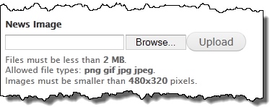
- Navigate to the location where the image is located on your PC.
- Click on the desired image.
- Click the Open button.
- At the Create News screen, click the Upload button.
- The screen now displays additional options for the uploaded image.
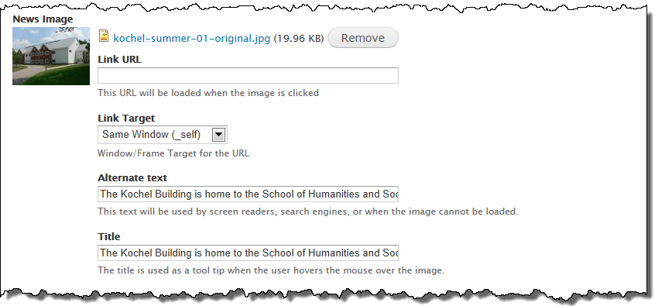
- In the Alternative Text box, enter a description that explains the purpose or content of that image.
- People who are blind use screen readers to read the text aloud. When a screen reader encounters an image, it will read the alt text to the person.
- In the Title box, type the title for the image.
- The title will be displayed if you hover your mouse over the image.)
- In the Caption box, type a caption for the image.
- If desired, you can choose to have the news item populate a right sidebar. To do so:
  - Scroll down to the Flags section (near the bottom, left side of the screen).
  - If the list of sidebars is not displayed, click on Flags.
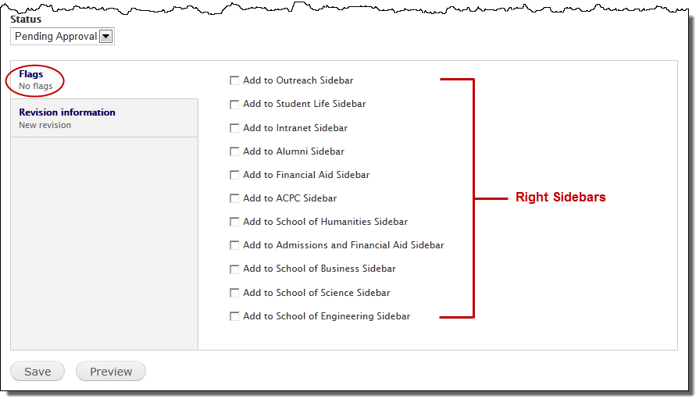
  - Click to place a checkmark in the box that corresponds to the section(s) where you want this item to display.
- Do not flag a news item for a sidebar outside of your section unless the content editor for that section has agreed to have the item displayed in their section.
- News items that are flagged to populate a sidebar will display in that sidebar until the flag is unchecked. Or if the sidebar has reached its display limit (usually four items), the oldest item will rotate off.

- Click the Save button.
Your news item will be submitted for approval. Once approved, you will be notified via email and the news item will appear on your dashboard. The news item is available to the public once you create a link to it. ??? --- Pending news item shows on Published & Pending Approval dashboard.

Create an Event
Events items are for any content that is related to a one-day or multiple-day event and they appear in the right sidebar of a section. Unlike pages and news items, events items will automatically disappear from the sidebar when the event is over.

Events will also be submitted to the Office of Marketing Communication for consideration for inclusion on the Penn State Behrend home page. Note: If an event item is chosen to appear on the home page, OMC may need to edit or add to the event to align with the standard college events format.

- From the primary Drupal menu, select: Add content.
- From the secondary Drupal menu, click on Event.
- In the Title box, type a title for the event using this format: Date: Event Title.
Example: May 15: Join Us for the Admissions Open House
- In the Location box, type the location of the event.
- In the Date(s) section:
  - If this is an all-day event where you do not want to display a beginning or ending time, click the All Day check box.
OR
If this is an event where you do want to display a beginning and an ending time, click the Show End Date check box.
- If Show End Date is unchecked, only the beginning date and time will display.
  - In the Beginning Date box, type or select the date from the pop-up calendar.
  - In the Beginning Time box, type the beginning time (specifying the hour and minutes) along with either am or pm.
- Minutes are limited to :00, :15, :30, and :45.
  - In the Ending Time box, type or select the ending date from the pop-up calendar.
  - In the Ending Time box, type the ending time (specifying the hour and minutes) along with either am or pm.
- Minutes are limited to :00, :15, :30, and :45.
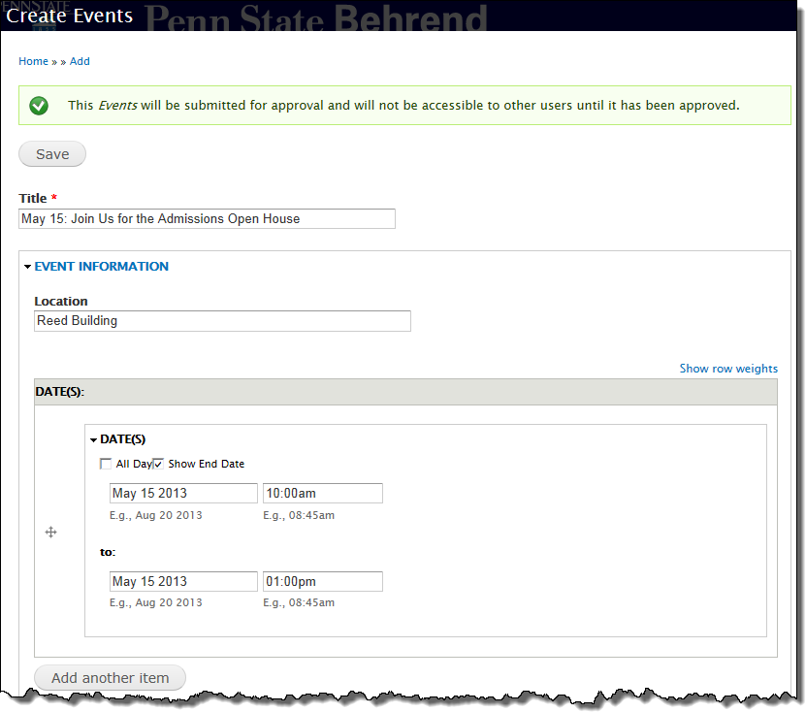
- If the event has multiple dates, click the Add Another Item button.
  - Repeat steps 4a to 4e.
- In the Body/Content area, type the event description and, if applicable, insert an image.
- From the Behrend Section menu, select the appropriate section.
- In the Event Contact Info section, type the contact person’s name, email, and phone number.
The phone number will automatically appear in the format of (814) 898-xxxx regardless of how it is entered into the field.
- If desired, you can choose to have the event item populate a right sidebar. To do so:
  - In the Flags section, place a checkmark in the box corresponding to section(s) where you want this item to display.
- Do not flag an event item for a sidebar outside of your section unless the content editor from that section has agreed to have the item displayed in their section.
- Event items that are flagged to populate a sidebar will display in that sidebar until either the flag is unchecked or until the event is over.
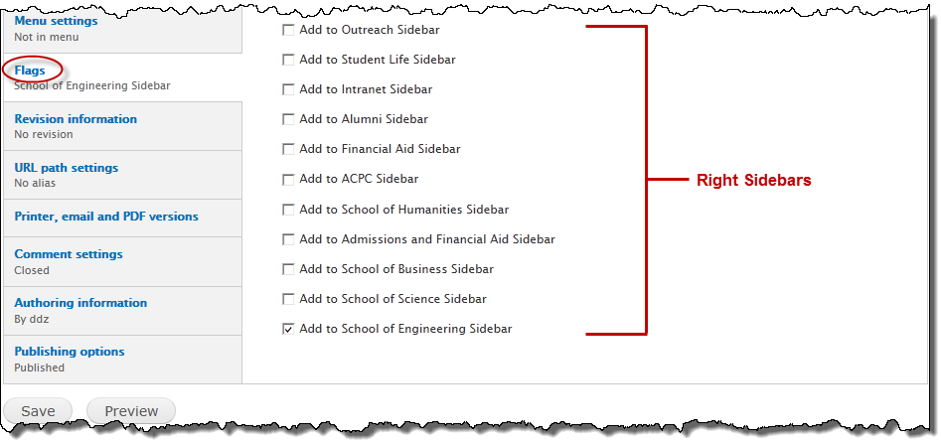
- Click the Save button.
Your event item will be submitted for review. Once approved, you will be notified via email and the event item will appear on your dashboard. The event item is available to the public once you create a link to it.
