EXAMPLE RESEARCH SUMMARY
You must include a separate title page that includes your instructor’s name, section, time/day the class meets, your name, student id #
Please read all of these boxes to make sure you are following instructions.
You will be writing a summary of a PEER REVIEWED research article.

Danielle Wilson
Your Name
Class and Section
Psych 100 Section 005
Time/Day the class meets
Tuesday Thursday 1:00PM
Instructor’s name
Ms. Trich Kremer
Student ID Number
913553226

Gesturing gives children new ideas about math
Article Title
The paper must be typed, double-spaced, and have 1-inch margins on all sides. It should be a minimum of 300 words.
The purpose of this study was to show how gesture can enhance math performance. It was an experimental research study that looked at how gesture effects children’s learning of math, particularly addition. The independent variable was gesture with three different conditions; gesture, no gesture, and partial gesture. The dependent variable of the study was the difference between pre- and post- test scores on a math task. The mediator variable was the speech being used during the lesson.
The lesson was where the independent variable changed. Participants were brought in for the study and were first given a demographics worksheet. Once their demographics were determined, they were given a pre-test to be aware of prior knowledge. Once the pre-test was graded, a lesson was given either with gesture that was grouping through two fingers, no gesture or a partial gesture which was just pointing. Once the lesson on the math was given, the post-test was given. The experimenters then determined a difference from pre- to post- tests scores.
What the study found
What the article was about
The major conclusion to this study was that the gesturing condition showed higher math scores than the partially correct which was higher than the no gesture condition, showing that the gesturing actually aided in the child remembering the math task by using their body to perform it.
However in this study there was no speech within the lesson. The only speech used was “This side is equal to the other side.” This was the only speech used within the lesson. Since this was the only speech, the lesson was highly dependent on the use of the gestures, which in my opinion could be questionable. The questions arise, should gesture be tested with more verbal instruction. Does the gesture give the same effect? One may also ask, does this relate to older or younger kids who are learning a different type of math?
Reference page below
Your opinion of the study
References
You will need a copy of the first page of the PEER REVIEWED article you chose after the reference page.
You will need a complete reference page for your article. This can be done in APA Style.
Goldin-Meadow, S., Cook, S. W, Mitchell, Z. A. (2009). Gesturing gives children new ideas about math. Current Directions in Psychological Science, 17(5), 313-317.

Print out the first page of the article and put it behind the reference page

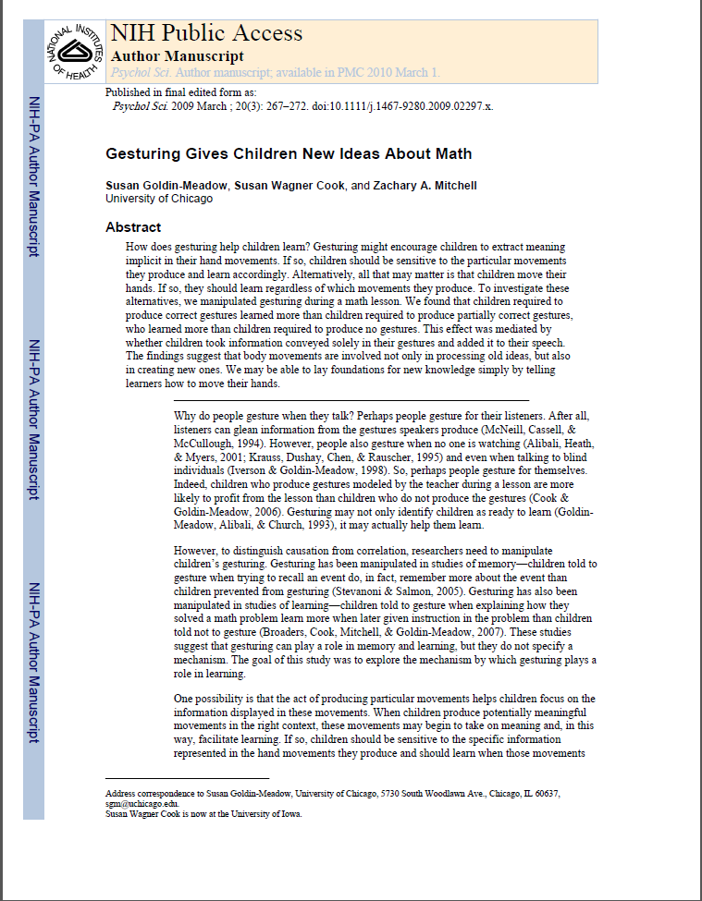

Here is a link to PsychArticles: http://search.proquest.com/psycarticles
Here is a link to PsychInfo: http://search.proquest.com/psycinfo
Examples of articles that are NOT peer reviewed are from TIME, Forbes, and Scientific American.
Databases like PsychINFO or PsychArticles should help you find great articles!
Try using the library’s databases to find peer reviewed journals.

