Institutional Equity and Diversity Committee
Summary Report

2014/15

Mission
The IEDC recommends and evaluates strategies and policies related to enhancing diversity and improving the campus climate at Penn State Behrend. It also provides advice and counsel on the college’s Strategic Plan for Diversity as it relates to the seven-point University-wide framework for diversity which includes:
- developing a shared and inclusive understanding of diversity
- creating a welcoming campus climate
- recruiting and retaining a diverse workforce
- developing a curriculum that fosters intercultural and international competencies
- diversifying leadership and management
- coordinating organizational change to support diversity goals
This committee helps to strengthen the college’s efforts to create a campus climate that promotes understanding, respect, and support for a diverse campus community through collaboration with the Office of Educational Equity and Diversity Programs, the Commission for Women Liaison Committee, the Multi-Cultural Council, and the Student Government Association Diversity Committee.

Contents
Committee Membership 2014/15 1
Academic Schools 1
HSS 1
Science 1
Engineering 1
Business 1
Staff 1
Students 1
Ex-Officio 1
Climate Subcommittee 2
Diversity Subcommittee 2
Mentoring Subcommittee 3
Student Life Subcommittee 4
Climate Discussion 4
Unity Week 5
Other Items 5

Committee Membership
2014/15

Academic Schools

HSS
- Angela Rood
- Carol Wilson

Science
- Grace Galinato
- Amos Ong

Engineering
- Ben Shadravan (never attended)
- Vacant

Business
- Randy Brown
- Val Vlad

Staff
- Faith Graham
- Margie Taylor
- Lindsey Hopkins Hall
- Lauri Enterline

Students
- Lola Soniregun – Multi-Cultural Council Representative
- Dimitri Fleuriot – SGA Diversity Committee Representative

Ex-Officio
- Dawn Blasko – Glenhill
- Sarah Whitney – Glenhill/Liaison Commission for Women
- Andy Herrera – Office of Educational Equity and Diversity Programs

The committee restructured various subcommittees it had in previous years. Current subcommittees and projects include:

Climate Subcommittee

Worked with Glenhill Administration and the Office of Educational Equity Programs in organizing various presentations/speakers on Diversity topics. Some of these included:

- Penn State, Title IX and You
- Gender Identity: What’s It All About?
- Gendered Spaces, Untied Laces: Transgender Children in Early Childhood Education
- Civility Online

Some of the workshops were also provided in collaboration with Behrend's Liaison Committee to the University Commission for Women, the Women’s Studies Minor, and the School of Humanities & Social Sciences.

Diversity Subcommittee

Recreated the IEEC website (www.behrend.psu.edu/IEDC) to include further information about the committee, current membership, and progress reports.
Started the development of a number of posters to promote community and respect on campus (sample below). Posters feature a diverse number of students with the words “I AM Behrend.” These are currently in production and will be on display throughout campus starting fall of 2015. It is possible that posters will eventually feature faculty and staff as well.
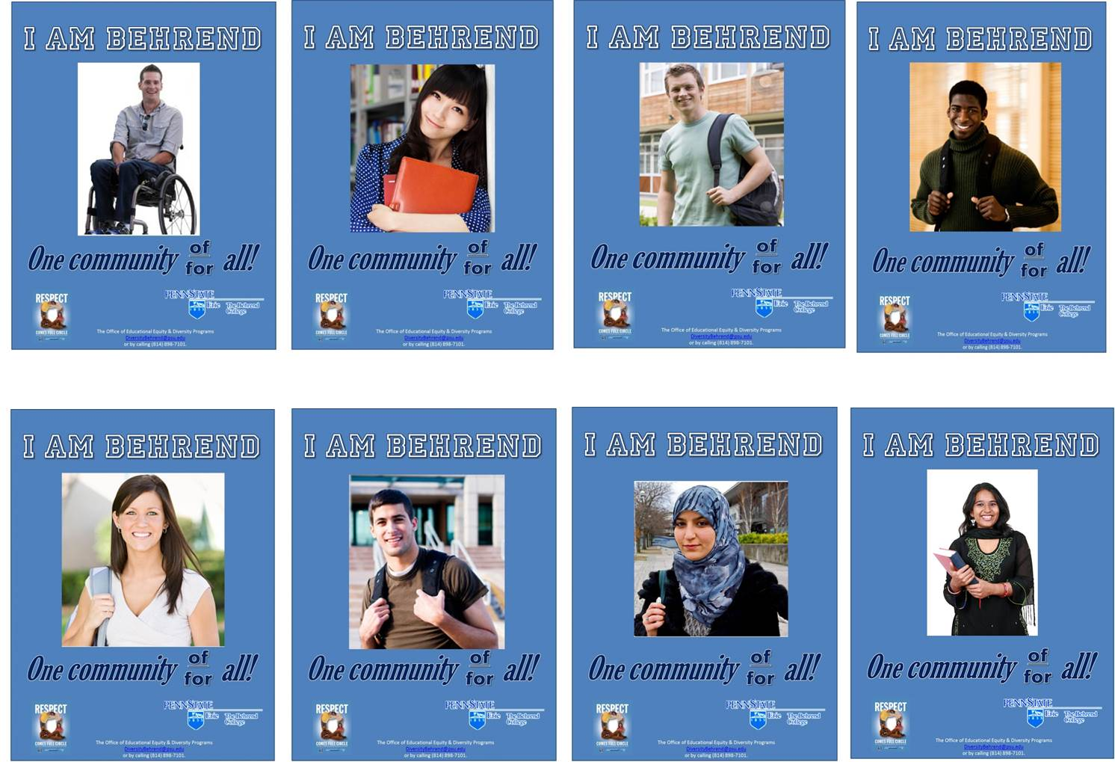
Figure 1: Smaple of Posters with Title saying "I AM BEHREND" followed by a photo of a student and then the words "One Community of/for all." There several small poster samples features students from various races and ethnicities

Mentoring Subcommittee

The issue of uniformity in faculty mentoring across academic Schools at Behrend was brought to the committee. The subcommittee examined the prospects of establishing a coherent faculty mentorship process. The subcommittee recognized that the Schools differ in structure and even perhaps in “departmental culture.” Thus, it would be challenging to set up one particular process for all the Schools. The subcommittee concluded that a one-form format providing various options for Schools to fill out at their discretion may be the best approach. This allows for flexibility, yet consistency among the Schools. See proposed form below:

Name: |  | Date:
Department and School:

For each category, choose from the following options:

- Assignment of Mentor
  - At the request of the mentee
  - Based on recommendation by Program Chair
  - Based on recommendation by (Asst.) Director
  - As offered by senior faculty/staff member
  - Other

- Duration of Mentorship Commitment
  - Two semesters
  - Three semesters
  - Four Semesters
  - Other

- Mentee-Mentor Progress Meetings
  - Once a year
  - Twice a year
  - Based on recommendation of (Asst.) Director
  - Other
- Person Monitoring the Progress of Mentee
  - Mentor
  - Program Chair
  - (Asst.) Director
  - Oher
- Evaluating the Progress of the Mentee
  - If mentee is on track by ____ semesters (see part C), then:
    - Mentee will not require a formal mentor
    - Mentee will still require a mentor until tenure
    - Mentee decides whether to continue the mentee-mentor relationship
  - If mentee is not on track by ____ semesters (see part C), then:
    - (Asst.) Director will recommend further guidelines that mentee should closely follow
    - Mentee will look for a different mentor
  - Other
- Evaluating the Progress of the Mentee
  - If mentee is on track by ____ semesters (see part C), then:
    - Mentee will not require a formal mentor
    - Mentee will still require a mentor until tenure
    - Mentee decides whether to continue the mentee-mentor relationship
  - If mentee is not on track by ____ semesters (see part C), then:
    - (Asst.) Director will recommend further guidelines that mentee should closely follow
    - Mentee will look for a different mentor
- Awarding the Efforts of the Mentor
  - Provide service credits
  - Provide course/time release
  - Other

To be submitted to: ______________________________________

Submitted by: __________________________________________

This form will be submitted to the Chancellor’s office for consideration. Implementation will depend on discussion and approval/rejection from School Directors and other relevant individuals.

Student Life Subcommittee
Climate Discussion
Ongoing discussion took place with one of the IEDC student members who is a first-year international student. He shared his observations on things that from his perspective worked well, and other that could improve. Topics included student mentorship, academic advising, and campus programming, among others. His input was shared with relevant units.
Unity Week
Various student organizations led by the Multi-Cultural Council (MCC) organized a number of cultural awareness activities throughout the year culminating with Unity Week during last week of classes. The goal of this event was to promote community, respect, cultural awareness, and unity on campus. Attendance was for the event was very strong.
T-shirts were distributed to students highlighting Penn State’s first principal--“I will respect the dignity of each individual within the Penn State Community.”

Other Items

Committee Leadership and Participation
In the past, Faculty members who have served in the committee have been appointed by School directors. In future years, members will be elected within the Faculty Council as this body has decided to establish a standing committee for diversity. Current faculty members serving in the IEDC will complete their two-year term and then be replaced by elected ones.

Staff will be invited to participate as current members complete their membership.

Students will be appointed by their individual student organizations (SGA and MCC).

There was discussion about the chairmanship of the committee. Ex-officio member, Andy Herrera, has served as chairperson of the IEDC for the last three years. He would like to provide the opportunity for others to serve in this role. A co-chairmanship was suggested, but no resolution was reached this year. Andy will continue on this role into the new academic year (2015/16).

