Procedure for Creating a Listserv/Email Alias
November 14, 2011

Alternative Format Statement
This publication is available in alternative media upon request.

Statement of Non-Discrimination
The Pennsylvania State University is committed to the policy that all persons shall have equal access to programs, facilities, admission, and employment without regard to personal characteristics not related to ability, performance, or qualifications as determined by University policy or by state or federal authorities. It is the policy of the University to maintain an academic and work environment free of discrimination, including harassment. The Pennsylvania State University prohibits discrimination and harassment against any person because of age, ancestry, color, disability or handicap, national origin, race, religious creed, sex, sexual orientation, or veteran status. Discrimination or harassment against faculty, staff, or students will not be tolerated at The Pennsylvania State University. Direct all inquiries regarding the nondiscrimination policy to the
Affirmative Action Director, The Pennsylvania State University, 328 Boucke Building, University Park, PA 16802-5901; Tel 814-865-4700/V, 814-863-1150/TTY.

Permission to copy all or part of this document is granted provided that the copies are not made or distributed for direct commercial advantage. In addition, any duplicated materials must be attributed to the Penn State Behrend Computer Center and include this credit notice. Direct any questions or requests to:
Carolyn Dudas
Penn State Behrend
Computer Center
4205 College Drive
Erie, PA 16563-1201
814-898-6458
ddz@psu.edu

Overview
These are the general steps to establish a listserv and its associated email alias:
- Apply for a listserv.
- Create a listserv password.
- Add subscribers to the listserv.
- Request an email alias.
- Test the email alias.

Note: It typically can take several days to a week or longer to complete this entire process, so plan accordingly.

At Behrend, if you need assistance, please contact a Computer Center staff member or the listserv support staff at U.P. (lsvmaint@psu.edu).

Helpful Tip
Listservs and email aliases must be unique within Penn State. To see if a listserv name or alias already exists, you can search for it.
- Go to Penn State’s home page (http://psu.edu).
- In the Find box, type the listserv name or email alias that you would like to use.
- Click the drop-down arrow and select to search: Penn State People.
- Click the Search button.

Part 1: Apply for a Listserv
Apply for a listserv that is to be used in conjunction with an alias.

- Go to http://lists.psu.edu and select this link under Administration: Request a New Mailing List.

- Complete and submit the form to request a new mailing list. (See the next page for an example of a completed form.) Here are some tips for completing the form.
  - List name:
    - Listserv names cannot exceed 25 characters.
    - Do not use these reserved words within the listserv name:
    - owner-*
    - -request
    - -search-request
    - -server
    - -signoff-request
    - -subscribe-request
    - -unsubscribe-request
    - Use the appropriate prefix. At Behrend, the prefix is “BD-“ (without the quotes).
Examples: BD-ComputerStaff, BD-OutdoorsClub
  - Short description: Enter a brief description or title for the listserv.
Examples: Computer Center Staff, Outdoors Club
  - Purpose of list: If the listserv will be used with an email alias, here is the suggested wording for this field: This listserv will be used in association with an email alias for the [name of college] [name of department]. Or: This listserv will be used in association with an email alias in order to distribute information about [topic]. Otherwise, describe the purpose of the list and any rules.
  - List owners: Designate 2 list owners!!
  - For a listserv/email alias, select these choices in response to the questions:
    - Closed - Who can join the list?
    - Public - Who can send mail to the list?
    - Sender - Where should replies be sent?
    - No - Control the membership using UMG?

- After submitting the form, you will receive an email (like the one below) indicating that your listserv will be created soon and to wait for further instructions.
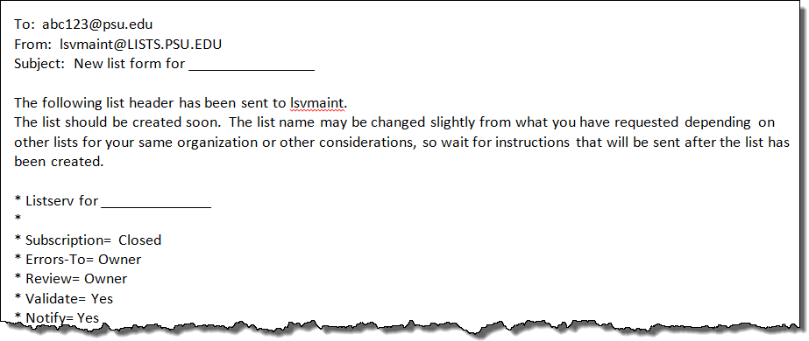

- continued –

- Within 2-3 days, you will receive an email to confirm the creation of your listserv. It will look similar to the message below and indicate that the listserv is ready to use.
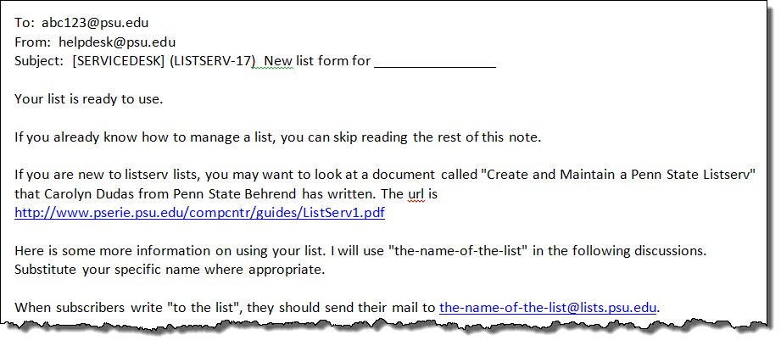

Example: Listserv Application Form
This is an example of a completed application form for the purpose of creating a listserv which will be associated with an email alias.
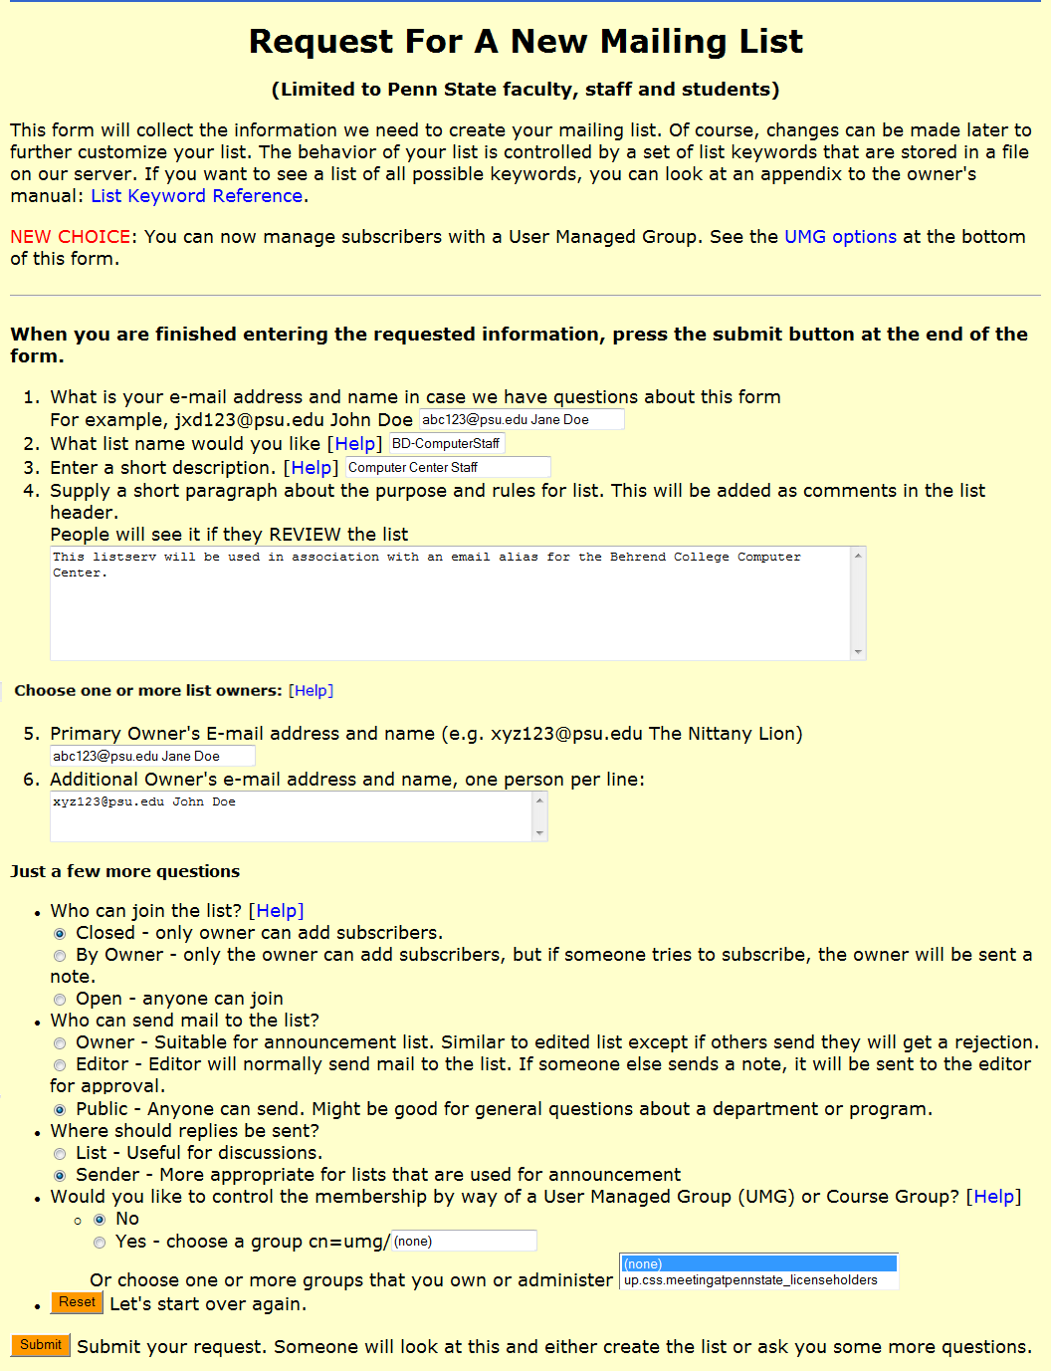

Part 2: Create a Listserv Password
After receiving an email that confirms the creation of your listserv, you must create a listserv password if haven’t previously done so.

- Go to http://lists.psu.edu and select this link under Administration: Mailing List Management Interface.

- At the Login page, select the link: get a new LISTSERV password to create a listserv password.
  - You must type your complete email address in the Email Address field.
Example: abc123@psu.edu
  - DO NOT use your email password as your listserv password!!

- You will receive an email asking you to confirm your password. You must confirm your password within 48 hours. To do so, click on the embedded link within the email notification.
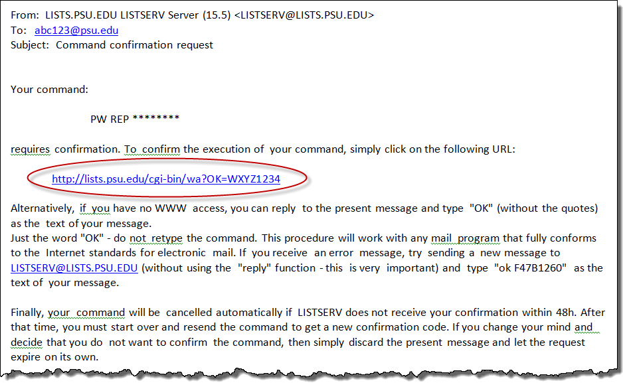

Part 3: Add Subscribers to the Listserv
You must add subscribers to the listserv. In the case of a listserv which is used in conjunction with an email alias, the subscribers are those who are designated to receive the email that is sent to the email alias.

- Go to http://lists.psu.edu and select this link under Administration: Mailing List Management Interface.

- Login using your email address (including the @psu.edu portion) and listserv password.

- From the Select List drop-down menu, click on the listserv name that you wish to configure.
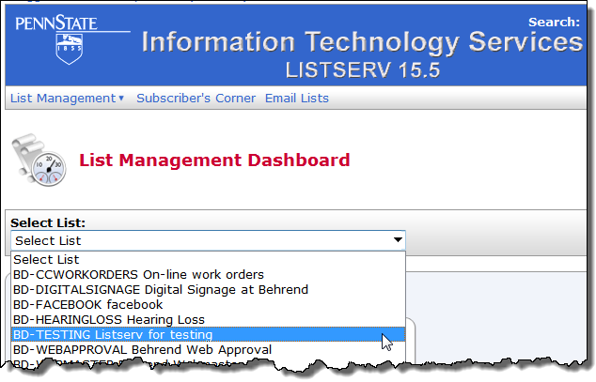

- Add subscribers (i.e. those who are to receive the messages from the email alias). To do so, from the menu, select: List Management/Subscriber Management.
  - Note: List owners do not automatically receive mail from the listserv.
  - You must add at least one list owner as a subscriber.
  - You can also do a bulk upload of subscribers. If you choose to do this, the email address must be complete (example: xyz123@psu.edu) and be in the first “column” of a plain text file. (Instructions for bulk uploads are not included in this document.)
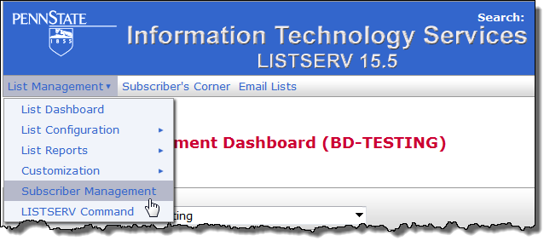

- continued –
- Complete the section of the form called Add New Subscriber. (To enter the person’s email address and name, follow one of the examples given below the box.) Click the Add button.
  - Repeat this step as many times as needed to add subscribers.
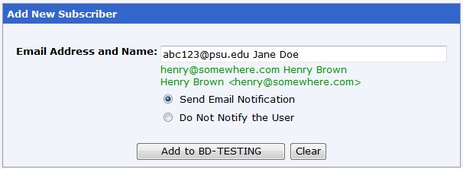

- Review the list membership (to proof the information that you entered for the subscribers). To do so, go to the section, Review List Members, and select: In Browser.
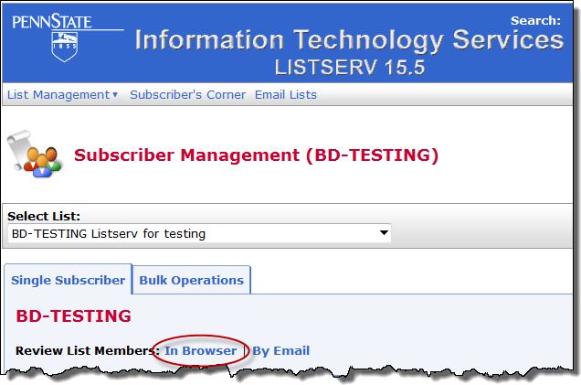
After you click on the In Browser link, a list of members is displayed.
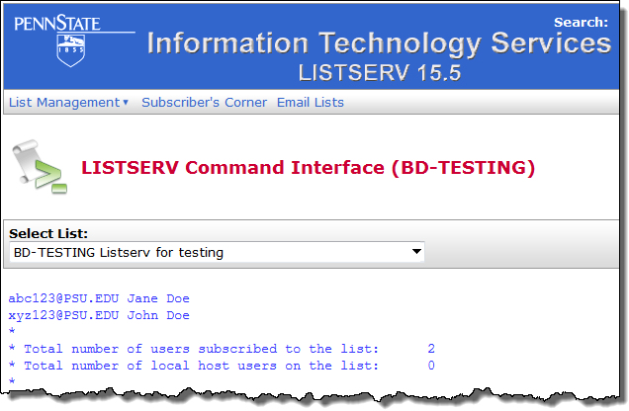
- Click Logout (in the upper right corner of screen).

Part 4: Request an Email Alias
You can request an email alias to be associated with a specific listserv.

- Send an email note to accounts@psu.edu to request an email alias for the listserv. (Tip: Send the email as a plain text message.) Include the listserv name and the requested name for the alias.
  - Be sure to use the complete listserv address --- including the @lists.psu.edu portion.
  - An email alias must be between 3 to 16 characters in length.
  - It is also advised that you send the email note as plain text.
  - It may take at least a week before you receive notification from Accounts that your email alias has been created.
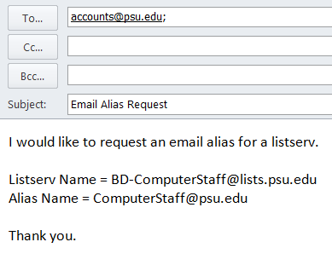

Part 5: Test the Email Alias

- Once you receive notification that the alias has been created, test the alias to see if it works. (Have someone send an email note to the alias. Anyone who is joined to the listserv as a subscriber should receive the email note.)

Congratulations! You can now use the email alias on your web page or other documentation.

