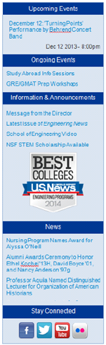
Overview of Sidebar
Information on the sidebar is organized into five sections:
- Upcoming Events
  - Automatically populated with up to five of the most recent event items from your section.
- Ongoing Events
  - Manually populated by the content editor.
- Information & Announcements
  - Manually populated by the content editor.
- News
  - Automatically populated with the three most recent news items from your section.
- Stay Connected
  - Manually populated by the Office of Marketing and Communication. It will contain icons and links to social media sites.

These sections appear in the order as shown above for consistency throughout the site. If there is no information for a particular section of the sidebar (such as Ongoing Events), then that section will not appear on the sidebar.

Cross Tagging
A new feature, cross tagging, is now available for the News and Upcoming Events sections. Cross tagging allows you to tag a specific news or event item and have it display in the sidebar of another department’s web page. Of course, you will need to obtain approval from the content editor of that section prior to cross tagging an item.

Upcoming Events (auto-populated)
This area is automatically populated with the five most recent event items from your section. If there are no upcoming event items, then the upcoming events section will not appear on the sidebar.

Example of the Upcoming Events section:
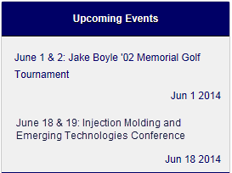

To create an upcoming event:
- Create an event.
  - From the primary Drupal menu, click: Add Content.
  - From the secondary Drupal menu, click: Event.

- Complete the following fields:
  - Title
  - Location
  - Dates and Times
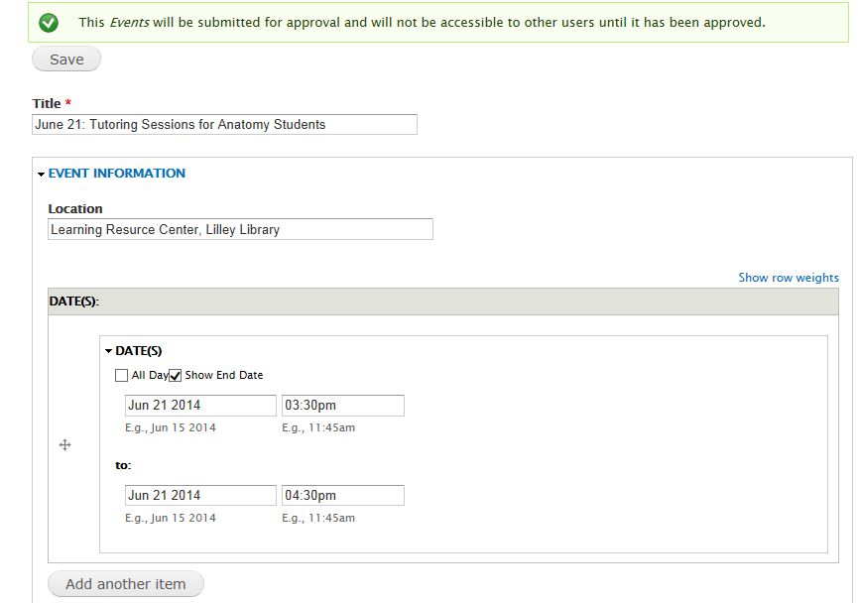

-continued-
- Body
- Behrend Section: Choose the section to which this event item will be posted.
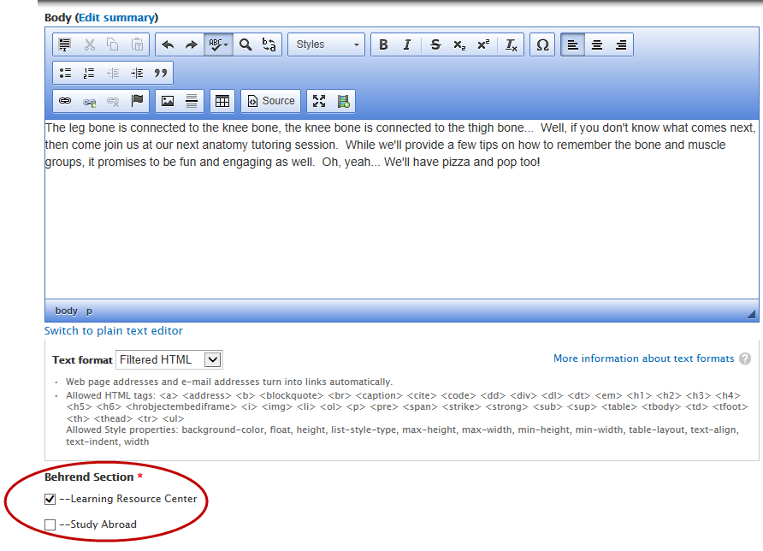
- Event Contact Name, Email, and Phone
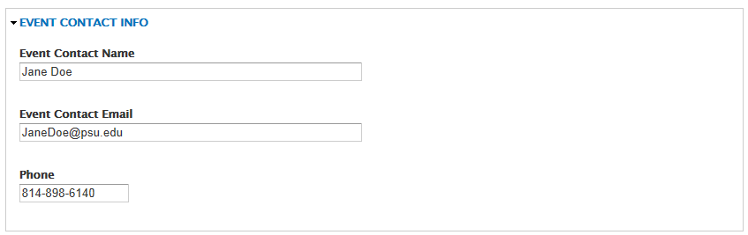

-continued-

- Save the event item.
- The event is now pending approval.
- While in View mode, you will see a gray section at the bottom of the page which contains information regarding tags.
  - Current Tags refers to the tags that are currently applied to the event item.
  - Additional Tags allows you to add a tag so that the news item is posted to another section within the web site.
  - The Full Tag List button opens a pop-up window so that you can see a list of all sections within the web site and the corresponding content editor(s) for those sections.
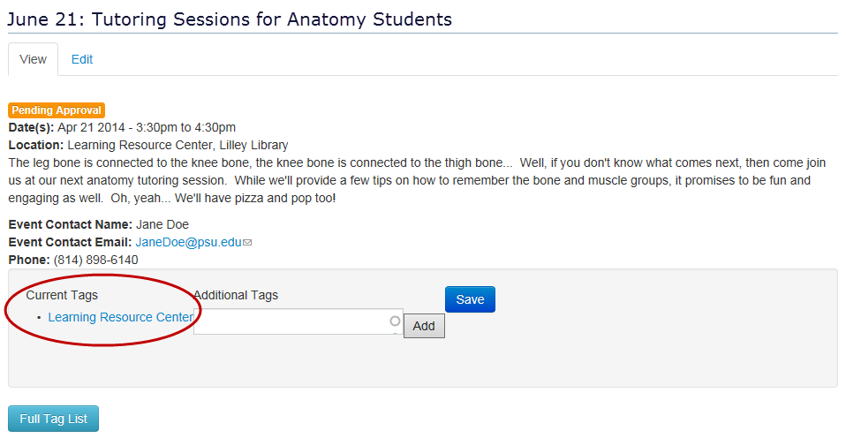

- After the event item has been approved, you can choose to post the event to another department’s sidebar (i.e. cross tagging).
  - As a courtesy, please ask the content editor of the other department if it’s OK to do so.
  - To begin the process, click on the Full Tag List button.
- This opens up a window with all of the sections within the web site. It also includes the corresponding content editor(s) for each section so that you know who to contact.
  - To select a tag, copy the heading for the desired section and then click the Close button.
- Examples of tags for the School of Science: School of Science, Academic Programs, Nursing
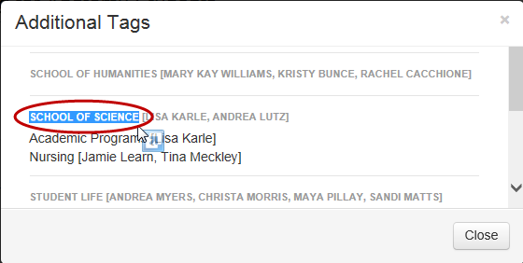

-continued-
- Paste the text into the box underneath Additional Tags.
- Click the Add button.
- Click the Save button.
- The newly added tag is shown under the Additional Tags heading.
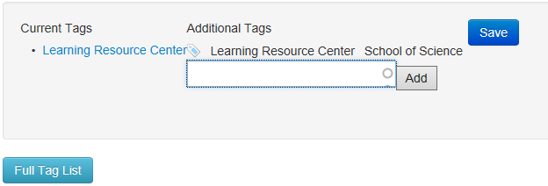
- Verify that the event is posted to your sidebar.
- Once an event item has expired (based upon its date), the event remains in published state. However, it will be removed from the Upcoming Events section of the sidebar.
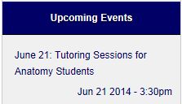

- If you chose to post to another section, verify that the event appears in the other department’s sidebar.
Example of an LRC event (i.e. Tutoring Sessions) which is displayed on the School of Science’s sidebar:
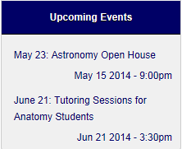

- To remove a tag that you added to a news or an event item, see the section “Remove a Tag” at the end of this document.

Ongoing Events (manually populated)
The content in this area is manually added or removed from this section of the sidebar.

Example of an Ongoing Events section:
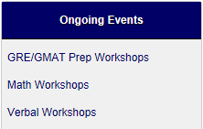

Note: If you do not currently have an Ongoing Events section on your sidebar, contact bdwebmaster@psu.edu to have it enabled.

To edit the Ongoing Events section:
- On the sidebar, hover over the section “Ongoing Events”.
- To the right of the title, an icon will appear that looks like a gear.
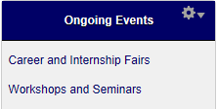
- Click the Gear icon.

- From the menu, select: Edit Block.

- Edit the body content by adding or removing links as needed.
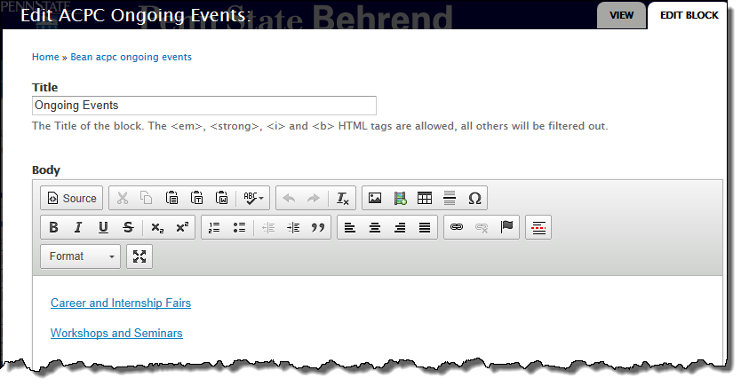
- Click the Save button.

Information & Announcements (manually populated)
The content in this area is manually added or removed from this section of the sidebar. This is also the area in which you can place small images, such as logos or icons.

Example of an Information & Announcements section:
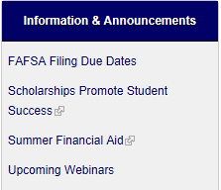

Note: If you do not currently have an Information & Announcements section on your sidebar, contact bdwebmaster@psu.edu to have it enabled.

To edit the Information & Announcements section:
- On the sidebar, hover over the section “Information and Announcements”.
- An icon that looks like a gear will appear to the right of the title.

- Click the Gear icon.

- From the menu, select: Edit Block.

- Edit the body content by adding or removing links as needed.
- You may also include small images, such as logos and icons, within this section.
- Image dimensions should be 200 x 200 pixels.

- Click the Save button.

News (auto populated)
The news area of the sidebar is automatically populated with the three most recent news items from your section. If there are no news items, then the news area of the sidebar will not appear.

Example of a News section:

Instructions on how to create a news item so that it appears in more than one section of the web site:
- Create a news item.
  - From the primary Drupal menu, click: Add Content.
  - From the secondary Drupal menu, click: News.

- Complete the following fields:
  - Title
  - Body
  - Behrend Section: Choose the appropriate section(s).
- If you have access to more than one section of the web site, you will see those sections listed. Make sure to click on the appropriate section for which you want the news item to be posted.
- If you forget to choose a section and click Save, then you will see the event page with an expanded list of Behrend sections. At this screen, you can only select a section that you have permission to access.
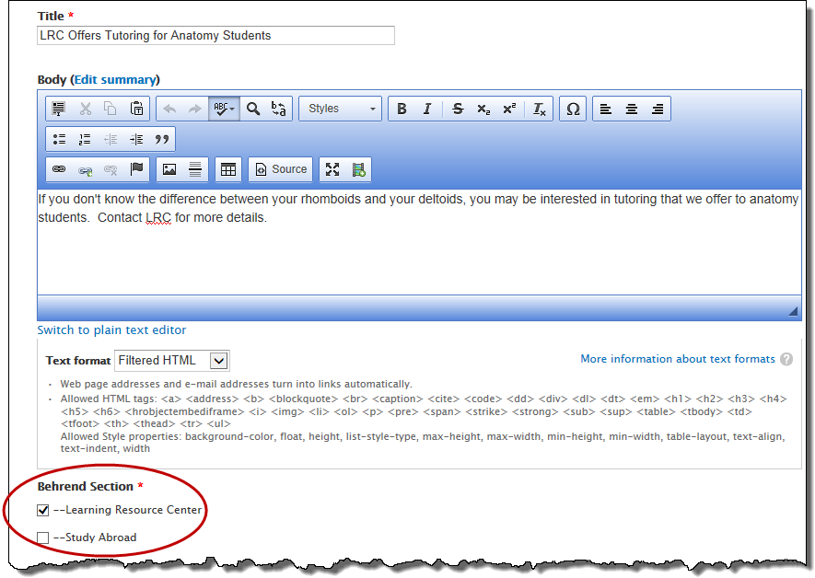
  - News Image
- If desired, browse and upload an image for the news item.
- If desired, provide the URL if you want to link the image to another page.
- Type the appropriate alt text for the image.

- Save the news item.
- The article is now pending approval.
- While in View mode, you will see a gray section at the bottom of the page which contains information regarding tags.
- Current Tags refers to the tags that are currently applied to the news item.
- Additional Tags allows you to add a tag so that the news item is posted to another section within the web site.
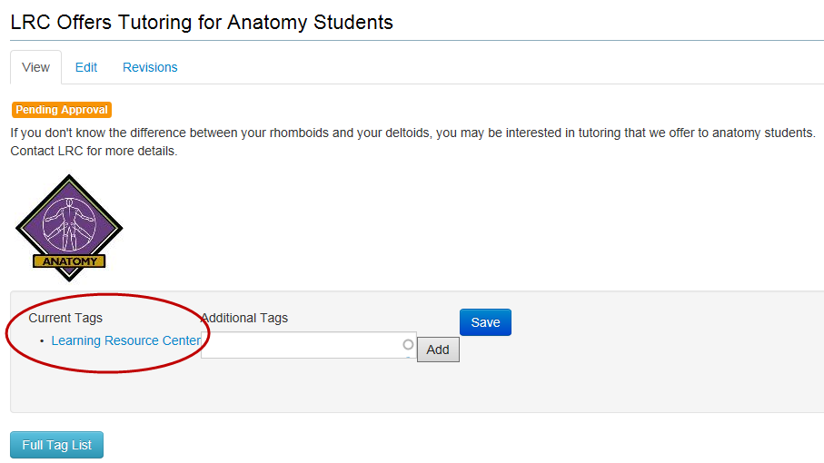
- After the news item has been approved, you can choose to post the news item to another department’s news sidebar (i.e cross tagging).
  - As a courtesy, please ask the content editor of the other department if it’s OK to do so.
  - To begin the process, click on the Full Tag List button.
- This opens up a pop-up window with all of the sections within the web site. It also includes the corresponding content editor(s) for each section so that you know who to contact.
  - To select a tag, copy the heading for the desired section and then click the Close button.
- Examples of tags for the School of Science: School of Science, Academic Programs, Nursing
  - Paste the text into the box underneath Additional Tags.

- Click the Add button.
- Click the Save button.
- The newly added tag is shown under the Additional Tags heading.
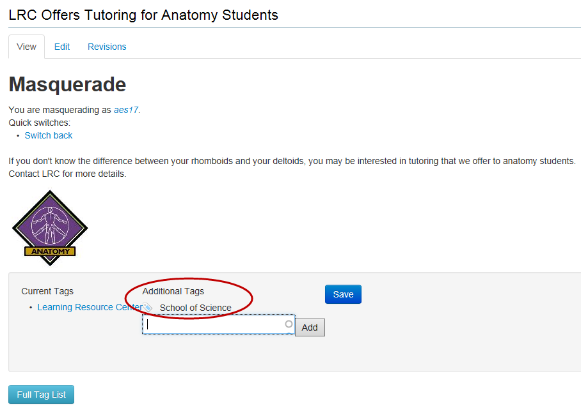
- Verify that the news item appears in your sidebar.
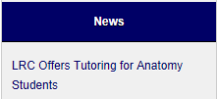

- If you chose to post to another section, verify that the news item appears in the other department’s sidebar.

Remove a Tag that You Added
To remove a tag that you added to a news or event item:
- Navigate to the page of your news or event item.

- While in View mode, scroll down towards the bottom of the page.

- Under Additional Tags, hover over the tag that you wish to remove.
- The tag changes color and has an “x” next to it.
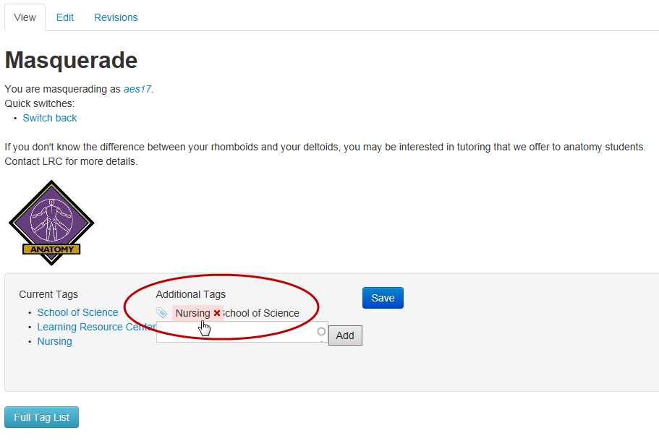
- Click the tag with the “x” to remove the tag.
- The news or event item is now removed from the sidebar for that department.

- Click the Save button.

- Verify that the news or event item has been removed from the other department’s sidebar.

Remove a Tag that Someone Else Added
To remove a tag that someone else added to a news or event item:
- Contact the author of that item (if known) or contact bdwebmaster@psu.edu.

