## Sign In to One Drive

First, you’ll need to sign-in to OneDrive.

1. Sit back and relax for approximately 5 minutes to allow some scripts to run in the background! 😊
   1. If you do NOT see the “Set Up OneDrive” window, then go to Windows File Explorer and click on the OneDrive icon which looks like this: OneDrive icon which looks like a blue cloud..
2. Once the scripts have been executed, you will see the “Set Up OneDrive” window.

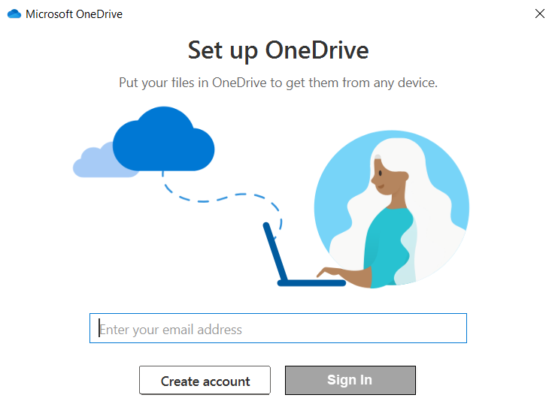

1. At the “Set Up OneDrive” window, type your PSU email address and click the **Sign In button**.
2. Login via Penn State WebAccess.
   1. Type your PSU User ID and password.
   2. Click the **Log in button**.

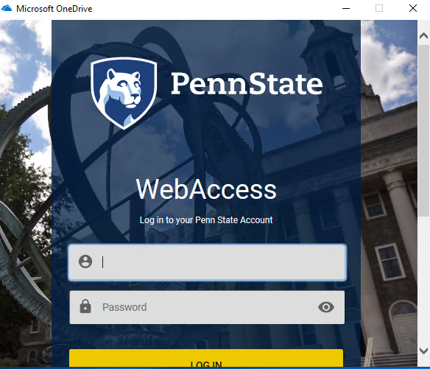

1. Authenticate via WebAccess.

* Don’t forget… You may need to use scroll bar or the Tab key to move to the next field.
  1. Select the desired device.
  2. Click on the appropriate button to complete the authentication process.

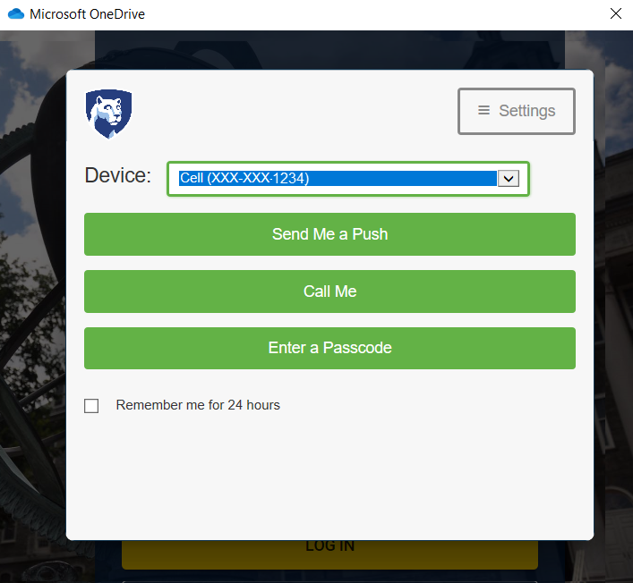

## Set Up Your OneDrive Folder

After you login and authenticate, you are now ready to begin setting up OneDrive.

1. At the “Your OneDrive Folder” window, click the **Next button**.

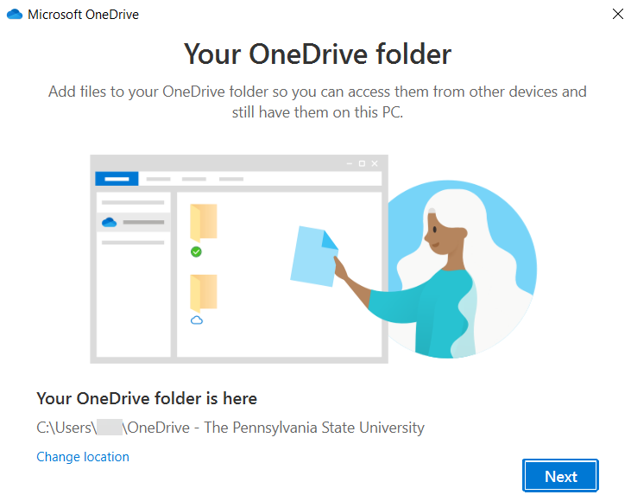

1. When you receive the prompt “A OneDrive Folder Already Exists on this PC”, click the **Use this Folder** **button**.

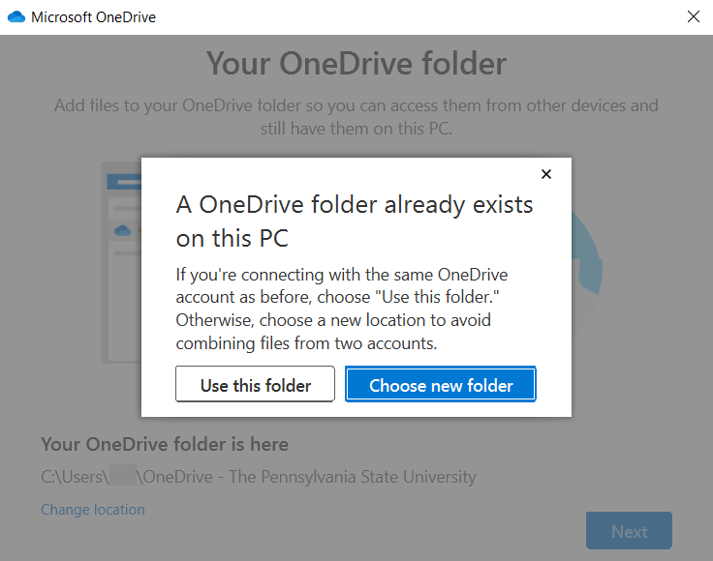

1. Click the **Next button** to move through the “Get to Know Your OneDrive” message screens.

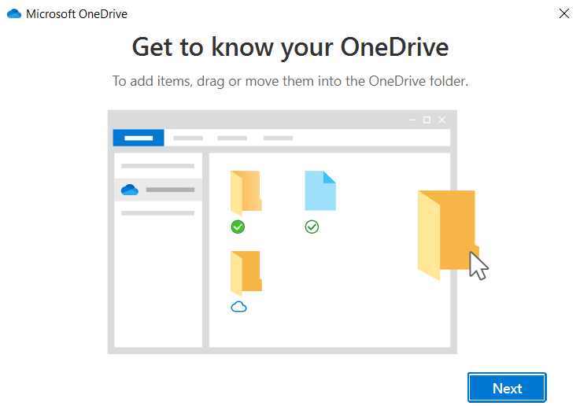

*-continued-*

1. At the “Your OneDrive is Ready for You” screen, click the **Open My OneDrive Folder button**.

This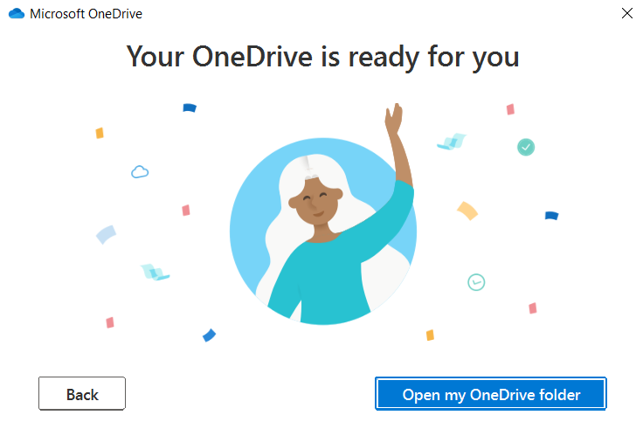

1. Your OneDrive should look like the image shown below, i.e. OneDrive – The Pennsylvania State University.

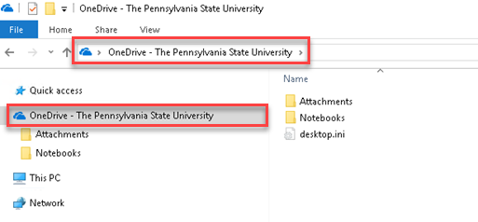

Congratulations! You’ve made it through the OneDrive set up.

All of your files will be redirected to the OneDrive cloud and you will be able to access them from anywhere. To do so, visit <https://office365.psu.edu>.